**IFT 530: ADVANCE DATABSE MANAGEMENT SYSTEMS**

**ANNMAY MANASI MANOJ KADVE**

**1226668900**

**PROJECT: PSHYCHOLOGY DATABASE MANAGEMENT SYSTEM**

**INSTRUCTOR: PROF. ASHISH GULATI**

**Introduction**

The Psychological Disorders Management System is a comprehensive and specialized database designed to facilitate the efficient management of patient information, therapeutic interventions, and medical interactions within the realm of mental health care. Developed as a part of the IFT 511 course under the guidance of Instructor Ashish Gulati, this project, led by Annmay Manasi Manoj Kadve, addresses the critical need for a streamlined system to organize, track, and analyze data related to patients, therapists, appointments, diagnoses, assessments, treatment plans, medications, and emergency contacts. By employing a relational database model, the system not only ensures data integrity but also provides valuable insights into the complex network of interactions associated with psychological disorders. Through carefully crafted tables, views, stored procedures, and audit mechanisms, this system aims to contribute to the enhancement of mental health care delivery by offering a structured and comprehensive platform for practitioners and administrators. The project embraces a multidimensional approach, recognizing the importance of both clinical and administrative aspects, to create a robust and user-friendly solution for the management of psychological disorders.

**Overview**

**System Architecture and Tables:**

The system's architecture revolves around a relational database model, a deliberate choice made to ensure not only the accuracy and consistency of the stored information but also to unlock the potential for in-depth analysis. The tables within the system are carefully curated to encapsulate the entire spectrum of mental health care, creating a cohesive and interconnected ecosystem.

**Patient Table:** At the heart of the system is the Patient table, capturing not just demographic data but fostering a nuanced understanding of each individual's unique mental health journey.

**Therapist Table:** Recognizing the pivotal role of mental health professionals, the Therapist table provides a comprehensive overview of therapists' specialties, ensuring an optimal match between patient needs and therapeutic expertise.

**Appointment Table:** A linchpin in managing the dynamic scheduling needs of mental health appointments, this table establishes connections between patients and therapists, fostering a seamless flow of information.

**Diagnosis Table:** Critical for understanding the evolving nature of psychological disorders, this table chronicles diagnosis details, creating a historical framework for tailored interventions.

**Assessment Table:** Enabling a data-driven approach to care, the Assessment table captures results and trends, empowering therapists with insights into the effectiveness of interventions over time.

**Treatment Plan Table:** This table acts as the blueprint for personalized care, documenting the strategies, goals, and timelines of interventions to guide practitioners in their therapeutic endeavors.

**Medication Table:** Ensuring precise medication management, this table correlates medications with patients and therapists, offering a comprehensive view of pharmaceutical interventions.

**Emergency Contact Table**: Recognizing the importance of a robust emergency response, this table identifies key contacts, providing a safety net for patients during critical situations.

**Need for the Management System:**

The imperative for the Psychological Disorders Management System arises from the escalating demand for a systematic and integrated approach to mental health care. Traditional methods of data management fall short in capturing the complexity of psychological disorders and the multifaceted nature of therapeutic interactions. This project responds to the pressing need for:

1. **Organization and Accessibility:** Streamlining patient data, therapeutic plans, and emergency contacts into a centralized system enhances accessibility, ensuring that critical information is readily available when needed.
2. **Data Analysis for Informed Decision-Making:** The relational database model facilitates the analysis of intricate relationships within mental health care, empowering practitioners and administrators to make informed decisions based on comprehensive insights.
3. **Enhanced Patient Care:** By addressing both clinical and administrative facets, the system aims to elevate the quality of patient care. From accurate diagnoses to personalized treatment plans, every aspect is meticulously considered to contribute to positive mental health outcomes.
4. **Efficiency in Collaboration:** The interconnected tables and relational model promote seamless collaboration between patients, therapists, and administrators, fostering a holistic and cooperative approach to mental health care delivery.

In essence, the Psychological Disorders Management System emerges not just as a project but as a progressive step towards revolutionizing mental health care administration, underscoring the importance of holistic and data-driven approaches in addressing the challenges of psychological disorders management.

DATABASE Table Design:

--Name:Annmay Manasi Manoj Kadve

--Subject: IFT 511

--Instructor: Ashish Gulati

--Project: Psychological Disorders Management System.

--Date of Submission: November 28 20233

-----------------Creating Database----------

-- Create the database

CREATE DATABASE ANNMA900;

-- Use the created database

USE ANNMA900;

-----------------Creating Tables---------------

-- Create the Patient table

CREATE TABLE Patient (

PatientID INT PRIMARY KEY,

FirstName VARCHAR(50),

LastName VARCHAR(50),

DateOfBirth DATE,

Gender VARCHAR(10),

ContactNumber VARCHAR(15),

Email VARCHAR(100),

Address VARCHAR(255),

EmergencyContactID INT,

InsuranceID INT

);

-- Create the Therapist table

CREATE TABLE Therapist (

TherapistID INT PRIMARY KEY,

FirstName VARCHAR(50),

LastName VARCHAR(50),

Specialty VARCHAR(100),

ContactNumber VARCHAR(15),

Email VARCHAR(100),

LicenseNumber VARCHAR(50)

);

-- Create the Appointment table

CREATE TABLE Appointment (

AppointmentID INT PRIMARY KEY,

PatientID INT,

TherapistID INT,

AppointmentDate DATE,

StartTime TIME,

EndTime TIME,

Status VARCHAR(20),

FOREIGN KEY (PatientID) REFERENCES Patient(PatientID),

FOREIGN KEY (TherapistID) REFERENCES Therapist(TherapistID)

);

-- Create the Diagnosis table

CREATE TABLE Diagnosis (

DiagnosisID INT PRIMARY KEY,

PatientID INT,

TherapistID INT,

DiagnosisDate DATE,

Description TEXT,

FOREIGN KEY (PatientID) REFERENCES Patient(PatientID),

FOREIGN KEY (TherapistID) REFERENCES Therapist(TherapistID)

);

-- Create the Assessment table

CREATE TABLE Assessment (

AssessmentID INT PRIMARY KEY,

PatientID INT,

TherapistID INT,

AssessmentDate DATE,

AssessmentType VARCHAR(50),

Score INT,

FOREIGN KEY (PatientID) REFERENCES Patient(PatientID),

FOREIGN KEY (TherapistID) REFERENCES Therapist(TherapistID)

);

-- Create the TreatmentPlan table

CREATE TABLE TreatmentPlan (

TreatmentPlanID INT PRIMARY KEY,

PatientID INT,

TherapistID INT,

StartDate DATE,

EndDate DATE,

Interventions TEXT,

Medication TEXT,

Goals TEXT,

FOREIGN KEY (PatientID) REFERENCES Patient(PatientID),

FOREIGN KEY (TherapistID) REFERENCES Therapist(TherapistID)

);

-- Create the Medication table

CREATE TABLE Medication (

MedicationID INT PRIMARY KEY,

PatientID INT,

TherapistID INT,

MedicationName VARCHAR(100),

Dosage VARCHAR(50),

Frequency VARCHAR(50),

FOREIGN KEY (PatientID) REFERENCES Patient(PatientID),

FOREIGN KEY (TherapistID) REFERENCES Therapist(TherapistID)

);

-- Create the EmergencyContact table

CREATE TABLE EmergencyContact (

EmergencyContactID INT PRIMARY KEY,

PatientID INT,

EmergencyContactName VARCHAR(100),

Relationship VARCHAR(50),

ContactNumber VARCHAR(15),

FOREIGN KEY (PatientID) REFERENCES Patient(PatientID)

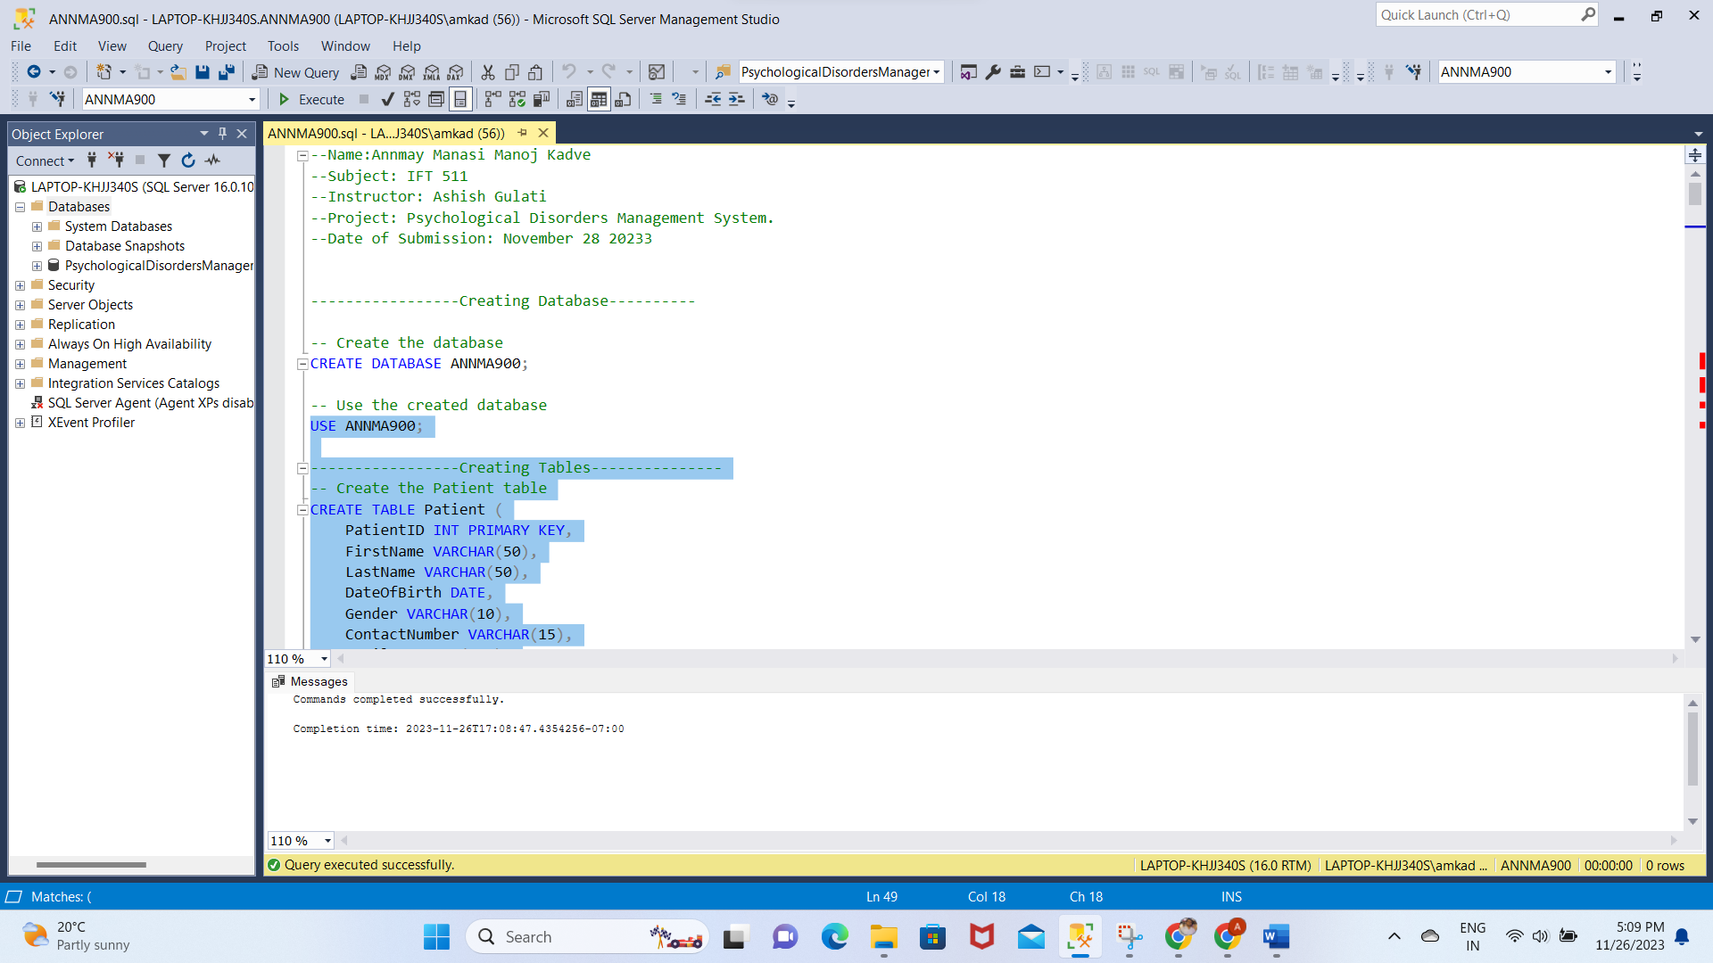

**ERD DIAGRAM:**

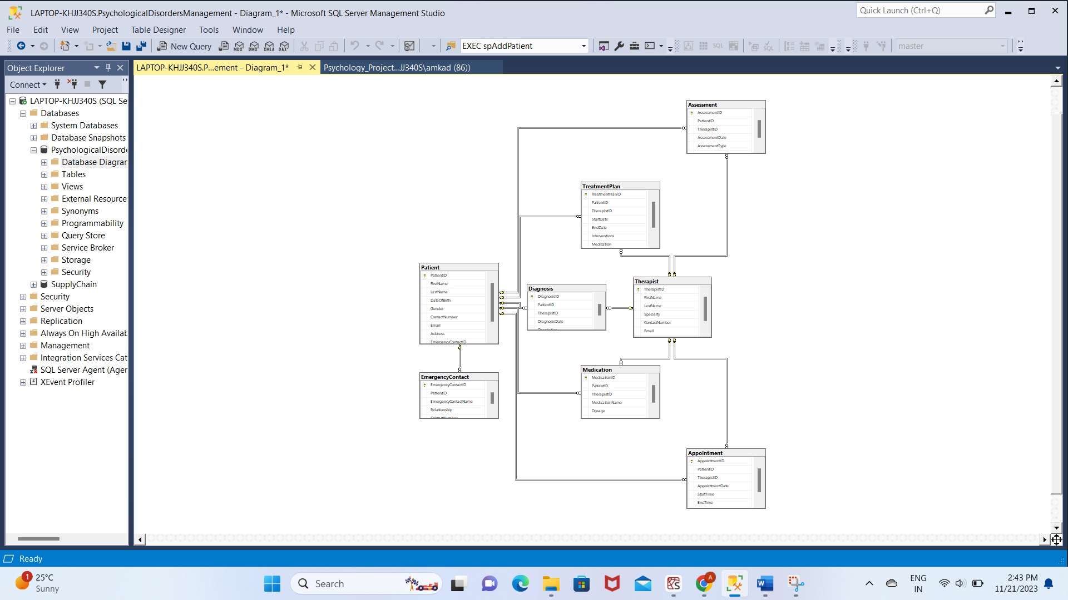

**Populating Tables:**

INSERT INTO Patient (PatientID, FirstName, LastName, DateOfBirth, Gender, ContactNumber, Email, Address, EmergencyContactID, InsuranceID)

VALUES

(1, 'John', 'Doe', '1980-01-15', 'Male', '123-456-7890', 'john.doe@email.com', '123 Main St, Cityville', 1, 1),

(2, 'Jane', 'Smith', '1995-05-22', 'Female', '987-654-3210', 'jane.smith@email.com', '456 Oak St, Townsville', 2, 2),

(3, 'David', 'Johnson', '1988-09-10', 'Male', '555-123-4567', 'david.johnson@email.com', '789 Pine St, Villagetown', 3, 3),

(4, 'Emily', 'Brown', '1992-03-07', 'Female', '777-888-9999', 'emily.brown@email.com', '101 Cedar St, Hamletsville', 4, 4),

(5, 'Michael', 'Jones', '1985-12-20', 'Male', '111-222-3333', 'michael.jones@email.com', '202 Elm St, Countryside', 5, 5),

(6, 'Amanda', 'Taylor', '1990-06-18', 'Female', '444-555-6666', 'amanda.taylor@email.com', '303 Maple St, Suburbia', 6, 6),

(7, 'Daniel', 'White', '1982-11-25', 'Male', '666-777-8888', 'daniel.white@email.com', '404 Birch St, Uptown', 7, 7),

(8, 'Olivia', 'Miller', '1998-04-30', 'Female', '999-000-1111', 'olivia.miller@email.com', '505 Walnut St, Downtown', 8, 8),

(9, 'William', 'Moore', '1987-08-14', 'Male', '222-333-4444', 'william.moore@email.com', '606 Oak St, Outskirts', 9, 9),

(10, 'Sophia', 'Lee', '1994-02-03', 'Female', '333-444-5555', 'sophia.lee@email.com', '707 Pine St, Riverside', 10, 10);

select*from Patient

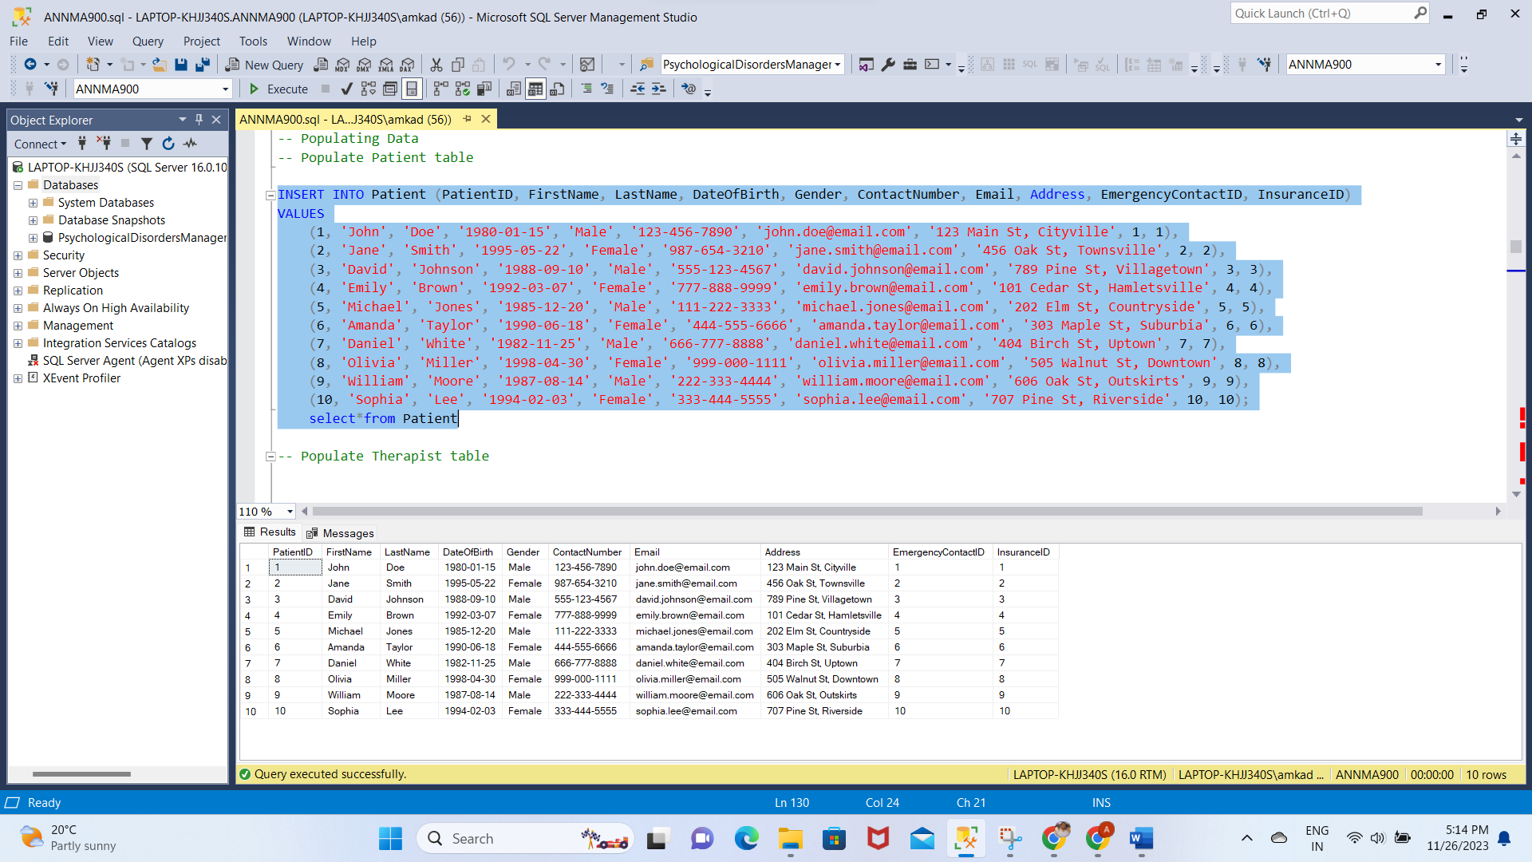

INSERT INTO Therapist (TherapistID, FirstName, LastName, Specialty, ContactNumber, Email, LicenseNumber)

VALUES

(1, 'Dr. Emily', 'Anderson', 'Clinical Psychologist', '555-777-8888', 'emily.anderson@email.com', 'DEF456'),

(2, 'Dr. Christopher', 'Moore', 'Counselor', '555-111-2222', 'christopher.moore@email.com', 'GHI789'),

(3, 'Dr. Amanda', 'Taylor', 'Psychiatrist', '555-444-5555', 'amanda.taylor@email.com', 'JKL012'),

(4, 'Dr. Daniel', 'White', 'Therapist', '555-666-7777', 'daniel.white@email.com', 'MNO345'),

(5, 'Dr. Jessica', 'Clark', 'Psychologist', '555-888-9999', 'jessica.clark@email.com', 'PQR678'),

(6, 'Dr. Kevin', 'Baker', 'Counseling Psychologist', '555-222-3333', 'kevin.baker@email.com', 'STU901'),

(7, 'Dr. Nicole', 'Hill', 'Mental Health Counselor', '555-333-4444', 'nicole.hill@email.com', 'VWX234'),

(8, 'Dr. David', 'Ward', 'Clinical Therapist', '555-555-6666', 'david.ward@email.com', 'YZA567'),

(9, 'Dr. Sarah', 'Evans', 'Psychiatrist', '555-999-0000', 'sarah.evans@email.com', 'BCD890'),

(10, 'Dr. Matthew', 'Fisher', 'Counselor', '555-000-1111', 'matthew.fisher@email.com', 'EFG123');

select*from Therapist

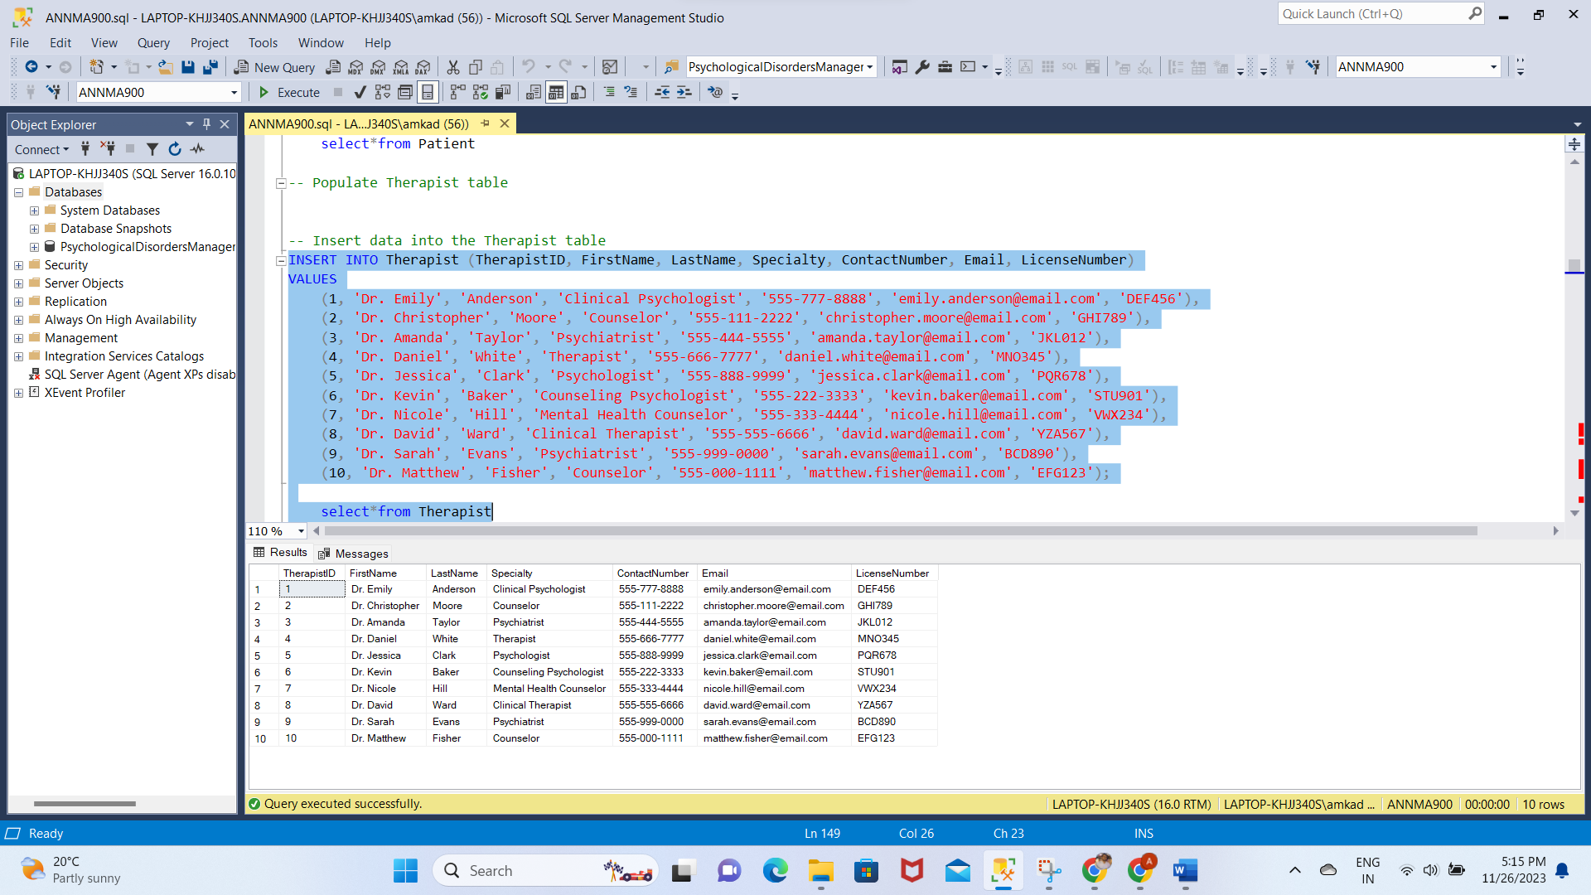

INSERT INTO Appointment (AppointmentID, PatientID, TherapistID, AppointmentDate, StartTime, EndTime, Status)

VALUES

(1, 1, 1, '2023-01-15', '11:30:00', '12:30:00', 'Scheduled'),

(2, 2, 2, '2023-01-18', '15:30:00', '16:30:00', 'Completed'),

(3, 1, 1, '2023-01-22', '10:00:00', '11:00:00', 'Canceled'),

(4, 2, 2, '2023-01-25', '14:30:00', '15:30:00', 'Scheduled'),

(5, 1, 1, '2023-01-28', '12:00:00', '13:00:00', 'Completed'),

(6, 2, 2, '2023-02-01', '16:00:00', '17:00:00', 'Scheduled'),

(7, 1, 1, '2023-02-05', '09:30:00', '10:30:00', 'Scheduled'),

(8, 2, 2, '2023-02-08', '14:00:00', '15:00:00', 'Completed'),

(9, 1, 1, '2023-02-12', '11:00:00', '12:00:00', 'Scheduled'),

(10, 2, 2, '2023-02-15', '15:00:00', '16:00:00', 'Scheduled'),

(11, 1, 1, '2023-02-19', '11:30:00', '12:30:00', 'Canceled'),

(12, 2, 2, '2023-02-22', '15:30:00', '16:30:00', 'Scheduled'),

(13, 1, 1, '2023-02-26', '10:00:00', '11:00:00', 'Scheduled'),

(14, 2, 2, '2023-03-01', '14:30:00', '15:30:00', 'Completed'),

(15, 1, 1, '2023-03-04', '12:00:00', '13:00:00', 'Scheduled'),

(16, 2, 2, '2023-03-08', '16:00:00', '17:00:00', 'Scheduled'),

(17, 1, 1, '2023-03-12', '09:30:00', '10:30:00', 'Completed'),

(18, 2, 2, '2023-03-15', '14:00:00', '15:00:00', 'Scheduled'),

(19, 1, 1, '2023-03-19', '11:00:00', '12:00:00', 'Scheduled'),

(20, 2, 2, '2023-03-22', '15:00:00', '16:00:00', 'Canceled');

select*from Appointment

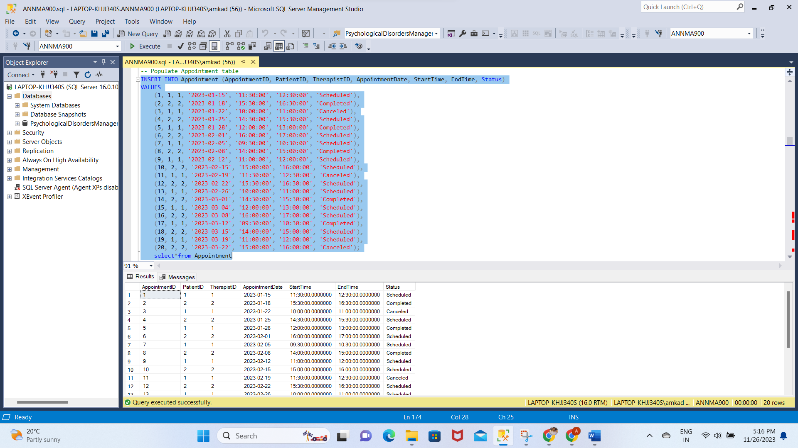

INSERT INTO Diagnosis (DiagnosisID, PatientID, TherapistID, DiagnosisDate, Description)

VALUES

(1, 1, 1, '2023-01-10', 'Major Depressive Disorder'),

(2, 2, 2, '2023-01-12', 'Generalized Anxiety Disorder'),

(3, 1, 1, '2023-02-05', 'Social Anxiety Disorder'),

(4, 2, 2, '2023-02-10', 'Panic Disorder'),

(5, 1, 1, '2023-02-20', 'Bipolar Disorder'),

(6, 2, 2, '2023-03-05', 'Obsessive-Compulsive Disorder'),

(7, 1, 1, '2023-03-15', 'Post-Traumatic Stress Disorder'),

(8, 2, 2, '2023-03-20', 'Attention-Deficit/Hyperactivity Disorder'),

(9, 1, 1, '2023-04-02', 'Schizophrenia'),

(10, 2, 2, '2023-04-10', 'Eating Disorder'),

(11, 1, 1, '2023-04-15', 'Borderline Personality Disorder'),

(12, 2, 2, '2023-04-22', 'Substance Use Disorder'),

(13, 1, 1, '2023-05-01', 'Autism Spectrum Disorder'),

(14, 2, 2, '2023-05-10', 'Schizoaffective Disorder'),

(15, 1, 1, '2023-05-18', 'Hoarding Disorder'),

(16, 2, 2, '2023-06-02', 'Body Dysmorphic Disorder'),

(17, 1, 1, '2023-06-15', 'Insomnia Disorder'),

(18, 2, 2, '2023-06-22', 'Disruptive Mood Dysregulation Disorder'),

(19, 1, 1, '2023-07-05', 'Specific Phobia'),

(20, 2, 2, '2023-07-12', 'Adjustment Disorder');

select*from Diagnosis

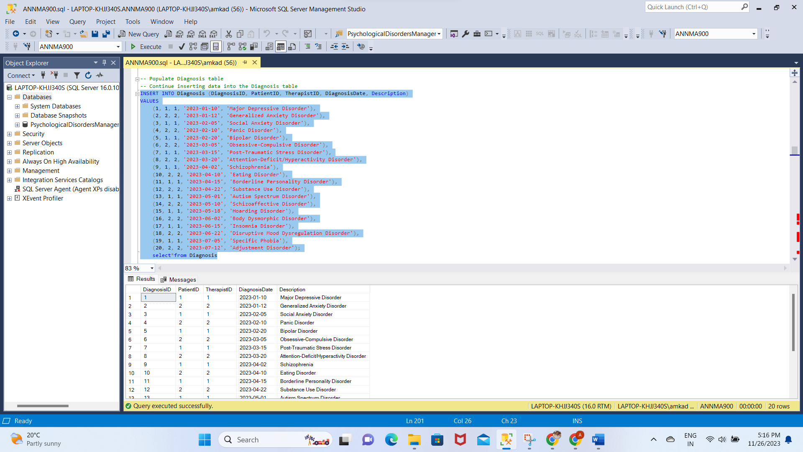

INSERT INTO Assessment (AssessmentID, PatientID, TherapistID, AssessmentDate, AssessmentType, Score)

VALUES

(1, 1, 1, '2023-01-12', 'Beck Depression Inventory', 20),

(2, 2, 2, '2023-01-14', 'Hamilton Anxiety Rating Scale', 25),

(3, 1, 1, '2023-02-15', 'PHQ-9', 12),

(4, 2, 2, '2023-02-18', 'GAD-7', 14),

(5, 1, 1, '2023-03-05', 'Beck Anxiety Inventory', 20),

(6, 2, 2, '2023-03-10', 'Hamilton Depression Rating Scale', 28),

(7, 1, 1, '2023-04-01', 'MADRS', 15),

(8, 2, 2, '2023-04-05', 'Yale-Brown Obsessive Compulsive Scale', 10),

(9, 1, 1, '2023-04-20', 'PANSS', 32),

(10, 2, 2, '2023-04-25', 'PTSD Checklist for DSM-5', 25),

(11, 1, 1, '2023-05-10', 'Montgomery-Asberg Depression Rating Scale', 18),

(12, 2, 2, '2023-05-15', 'State-Trait Anxiety Inventory', 22),

(13, 1, 1, '2023-06-02', 'Zung Self-Rating Depression Scale', 14),

(14, 2, 2, '2023-06-10', 'Obsessive-Compulsive Inventory - Revised', 30),

(15, 1, 1, '2023-07-01', 'Generalized Anxiety Disorder 7', 16),

(16, 2, 2, '2023-07-05', 'Columbia-Suicide Severity Rating Scale', 2),

(17, 1, 1, '2023-08-20', 'Patient Health Questionnaire-15', 10),

(18, 2, 2, '2023-08-25', 'Rosenberg Self-Esteem Scale', 28),

(19, 1, 1, '2023-09-10', 'Social Phobia Inventory', 24),

(20, 2, 2, '2023-09-15', 'Childhood Trauma Questionnaire', 35);

select*from Assessment

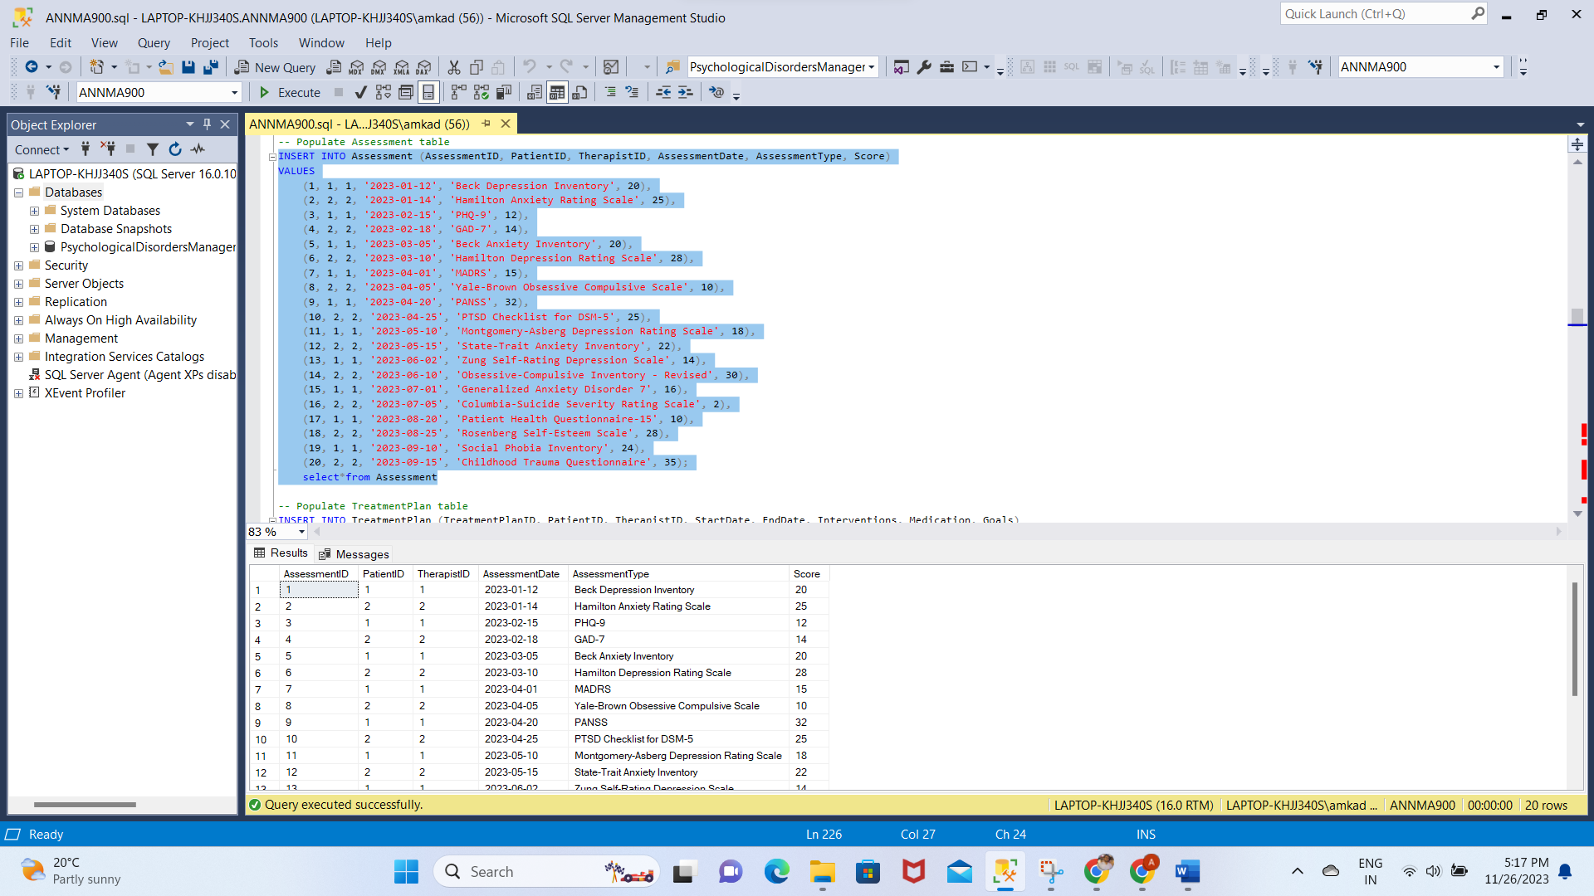

INSERT INTO TreatmentPlan (TreatmentPlanID, PatientID, TherapistID, StartDate, EndDate, Interventions, Medication, Goals)

VALUES

(1, 1, 1, '2023-01-15', '2023-02-15', 'Cognitive Behavioral Therapy', 'SSRI Antidepressant', 'Improve mood and daily functioning'),

(2, 2, 2, '2023-01-17', '2023-02-17', 'Mindfulness Meditation', 'Benzodiazepine', 'Reduce anxiety symptoms'),

(3, 1, 1, '2023-03-01', '2023-04-30', 'Mindfulness-Based Stress Reduction', 'None', 'Stress reduction and relaxation'),

(4, 2, 2, '2023-04-01', '2023-05-31', 'Dialectical Behavior Therapy', 'Antipsychotic Medication', 'Emotion regulation and interpersonal effectiveness'),

(5, 1, 1, '2023-05-01', '2023-06-30', 'Family Therapy', 'Mood Stabilizer', 'Improve family dynamics and communication'),

(6, 2, 2, '2023-06-01', '2023-07-31', 'Narrative Therapy', 'Selective Serotonin-Norepinephrine Reuptake Inhibitor', 'Explore personal narratives and coping strategies'),

(7, 1, 1, '2023-08-01', '2023-09-30', 'Art Therapy', 'Atypical Antipsychotic', 'Creative expression and emotional exploration'),

(8, 2, 2, '2023-10-01', '2023-11-30', 'Play Therapy', 'Anxiolytic Medication', 'Childhood trauma processing and anxiety reduction'),

(9, 1, 1, '2023-12-01', '2024-01-31', 'Solution-Focused Brief Therapy', 'SSRI Antidepressant', 'Goal setting and solution-focused strategies'),

(10, 2, 2, '2024-02-01', '2024-03-31', 'Gestalt Therapy', 'Antianxiety Medication', 'Holistic self-awareness and present-focused exploration'),

(11, 1, 1, '2024-04-01', '2024-05-31', 'Acceptance and Commitment Therapy', 'Mood Stabilizer', 'Mindfulness and values-driven actions'),

(12, 2, 2, '2024-06-01', '2024-07-31', 'Person-Centered Therapy', 'Anxiolytic Medication', 'Client-centered exploration of self'),

(13, 1, 1, '2024-08-01', '2024-09-30', 'Couples Therapy', 'Antidepressant Medication', 'Enhance communication and relational satisfaction'),

(14, 2, 2, '2024-10-01', '2024-11-30', 'Schema Therapy', 'Atypical Antipsychotic', 'Address maladaptive cognitive patterns and behaviors'),

(15, 1, 1, '2024-12-01', '2025-01-31', 'Biofeedback Therapy', 'SSRI Antidepressant', 'Enhance self-regulation and stress management'),

(16, 2, 2, '2025-02-01', '2025-03-31', 'Equine-Assisted Psychotherapy', 'Selective Serotonin Reuptake Inhibitor', 'Explore emotions through interaction with horses'),

(17, 1, 1, '2025-04-01', '2025-05-31', 'Neurofeedback Therapy', 'Antipsychotic Medication', 'Train brain patterns for improved mental functioning'),

(18, 2, 2, '2025-06-01', '2025-07-31', 'Music Therapy', 'Anxiolytic Medication', 'Utilize music for emotional expression and coping'),

(19, 1, 1, '2025-08-01', '2025-09-30', 'Transcranial Magnetic Stimulation (TMS)', 'Mood Stabilizer', 'Non-invasive brain stimulation for mood improvement'),

(20, 2, 2, '2025-10-01', '2025-11-30', 'Reality Therapy', 'Antidepressant Medication', 'Focus on present behavior and choices for personal fulfillment');

select*from TreatmentPlan

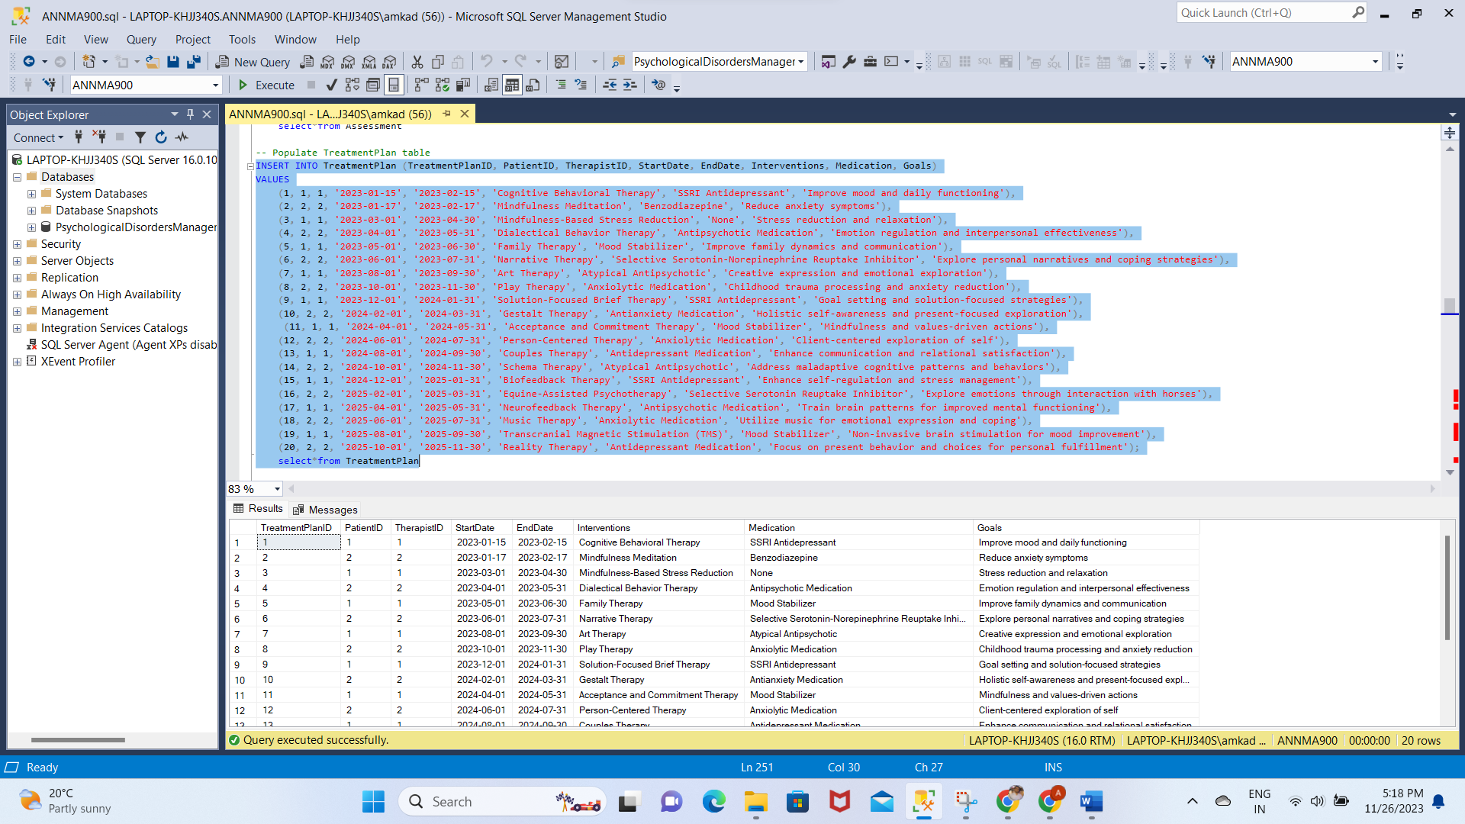

-- Populate Medication table

INSERT INTO Medication (MedicationID, PatientID, TherapistID, MedicationName, Dosage, Frequency)

VALUES

(1, 1, 1, 'Prozac', '20mg', 'Once a day'),

(2, 2, 2, 'Xanax', '0.5mg', 'As needed'),

(3, 1, 1, 'Wellbutrin', '150mg', 'Once daily'),

(4, 2, 2, 'Lexapro', '10mg', 'Once daily'),

(5, 1, 1, 'Zoloft', '50mg', 'Once daily'),

(6, 2, 2, 'Ativan', '1mg', 'As needed'),

(7, 1, 1, 'Celexa', '20mg', 'Once daily'),

(8, 2, 2, 'Klonopin', '0.5mg', 'As needed'),

(9, 1, 1, 'Effexor', '75mg', 'Once daily'),

(10, 2, 2, 'Valium', '5mg', 'As needed'),

(11, 1, 1, 'Paxil', '30mg', 'Once daily'),

(12, 2, 2, 'Buspar', '15mg', 'Twice daily'),

(13, 1, 1, 'Trintellix', '20mg', 'Once daily'),

(14, 2, 2, 'Risperdal', '1mg', 'Once daily'),

(15, 1, 1, 'Abilify', '10mg', 'Once daily'),

(16, 2, 2, 'Seroquel', '50mg', 'Once daily'),

(17, 1, 1, 'Remeron', '15mg', 'Once daily'),

(18, 2, 2, 'Lamictal', '25mg', 'Once daily'),

(19, 1, 1, 'Geodon', '80mg', 'Twice daily'),

(20, 2, 2, 'Lyrica', '75mg', 'Twice daily');

select*from Medication

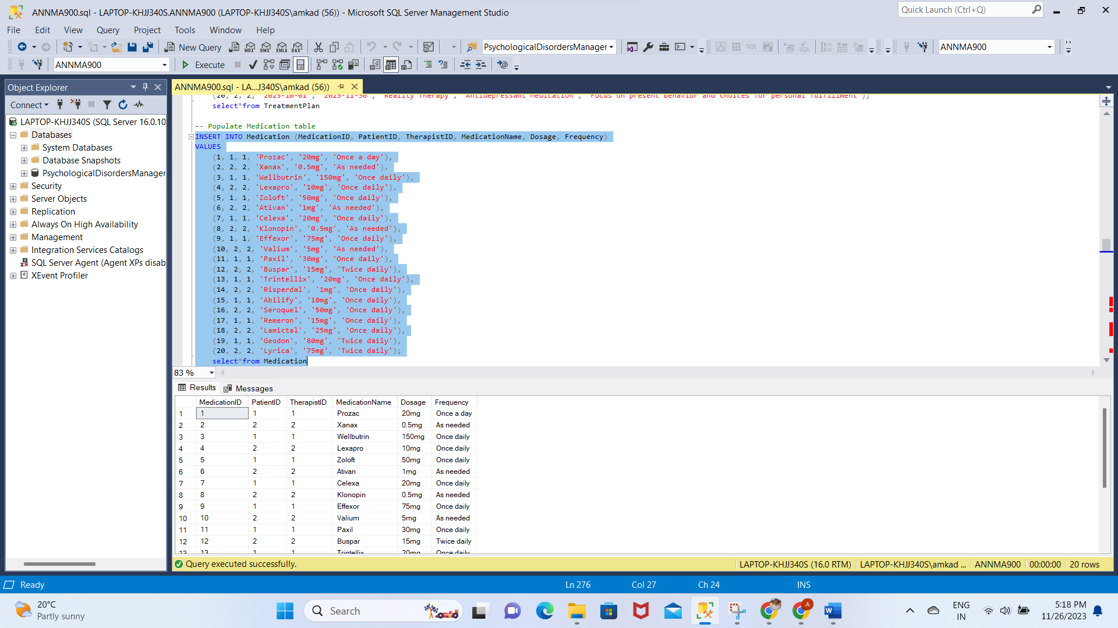

-- Populate EmergencyContact table

INSERT INTO EmergencyContact (EmergencyContactID, PatientID, EmergencyContactName, Relationship, ContactNumber)

VALUES

(1, 1, 'Alice Doe', 'Spouse', '1112223333'),

(2, 2, 'Bob Smith', 'Sibling', '4445556666'),

(3, 1, 'David Doe', 'Brother', '555-555-5555'),

(4, 2, 'Emily Smith', 'Friend', '555-666-6666'),

(5, 1, 'Susan Johnson', 'Aunt', '555-777-7777'),

(6, 2, 'Daniel Williams', 'Cousin', '555-888-8888'),

(7, 1, 'Chris Doe', 'Father', '555-999-9999'),

(8, 2, 'Olivia Smith', 'Sister', '555-000-0000'),

(9, 1, 'Grace Johnson', 'Grandmother', '555-111-2222'),

(10, 2, 'William Williams', 'Grandfather', '555-333-4444');

SELECT*FROM EmergencyContact

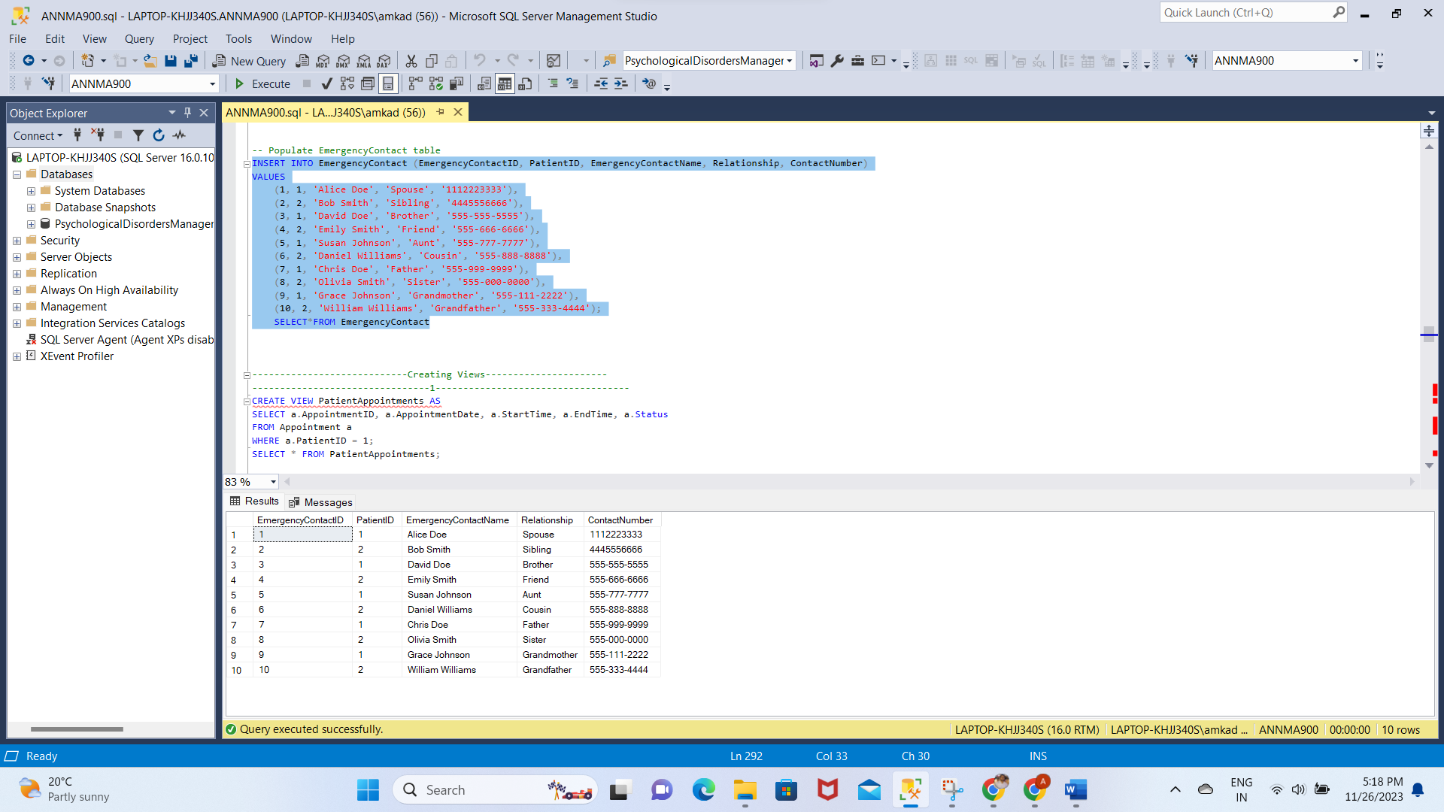

**Creating Views:**

1. CREATE VIEW PatientAppointments AS

SELECT a.AppointmentID, a.AppointmentDate, a.StartTime, a.EndTime, a.Status

FROM Appointment a

WHERE a.PatientID = 1;

SELECT * FROM PatientAppointments;

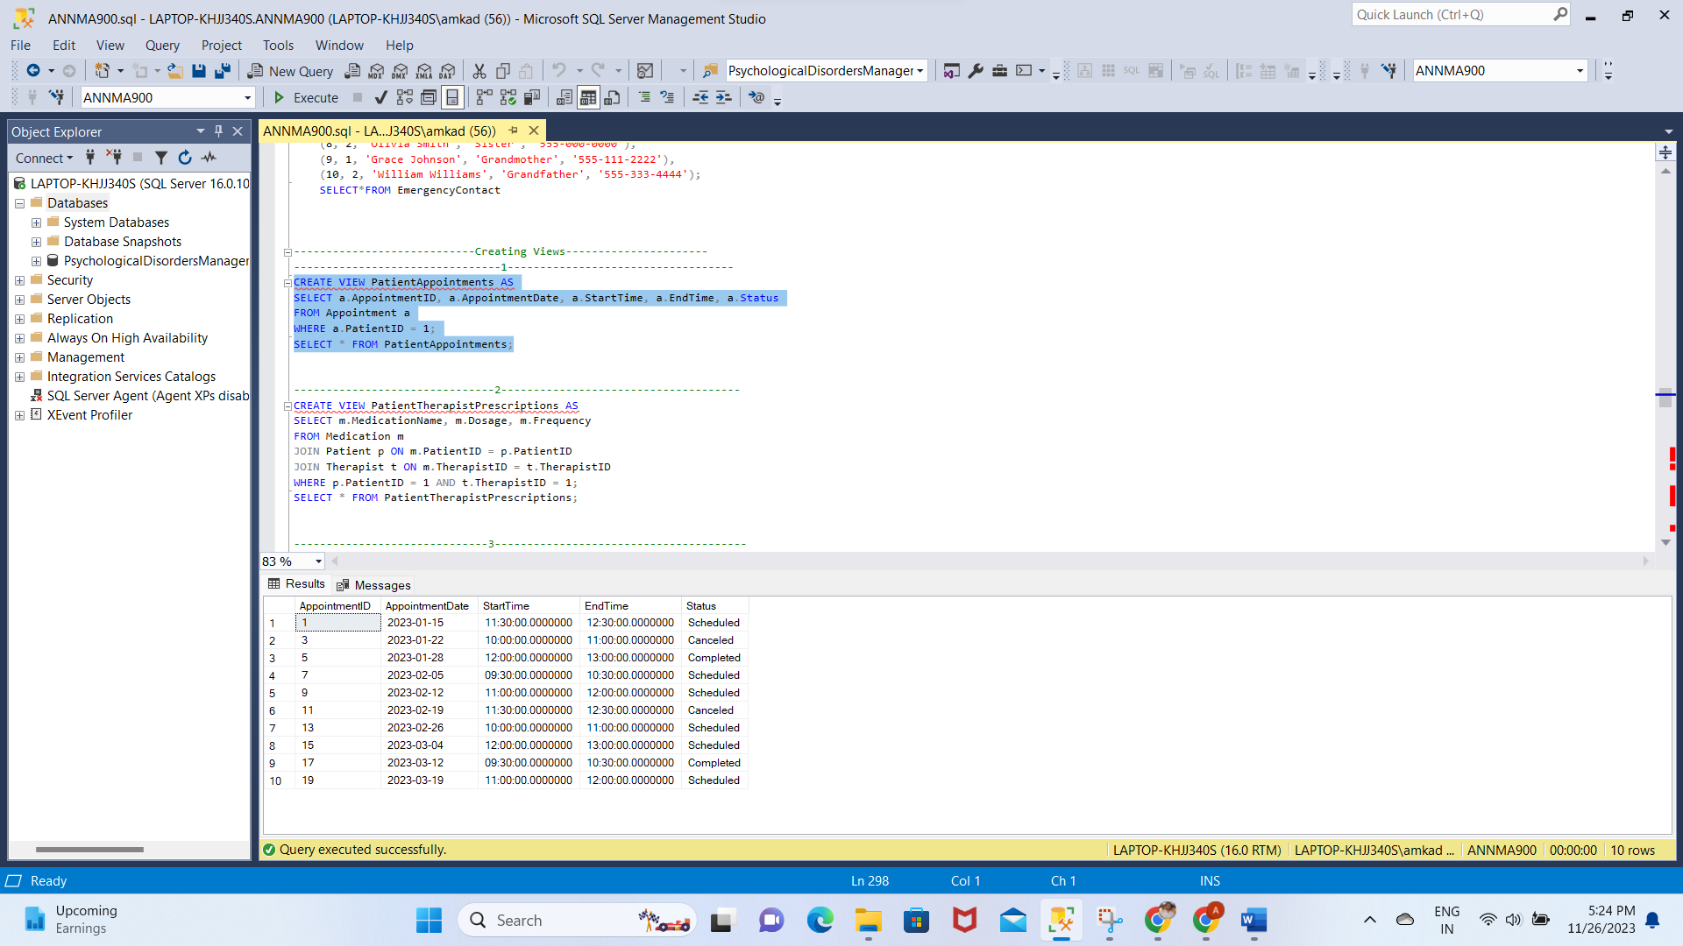

1. CREATE VIEW PatientTherapistPrescriptions AS

SELECT m.MedicationName, m.Dosage, m.Frequency

FROM Medication m

JOIN Patient p ON m.PatientID = p.PatientID

JOIN Therapist t ON m.TherapistID = t.TherapistID

WHERE p.PatientID = 1 AND t.TherapistID = 1;

SELECT * FROM PatientTherapistPrescriptions;

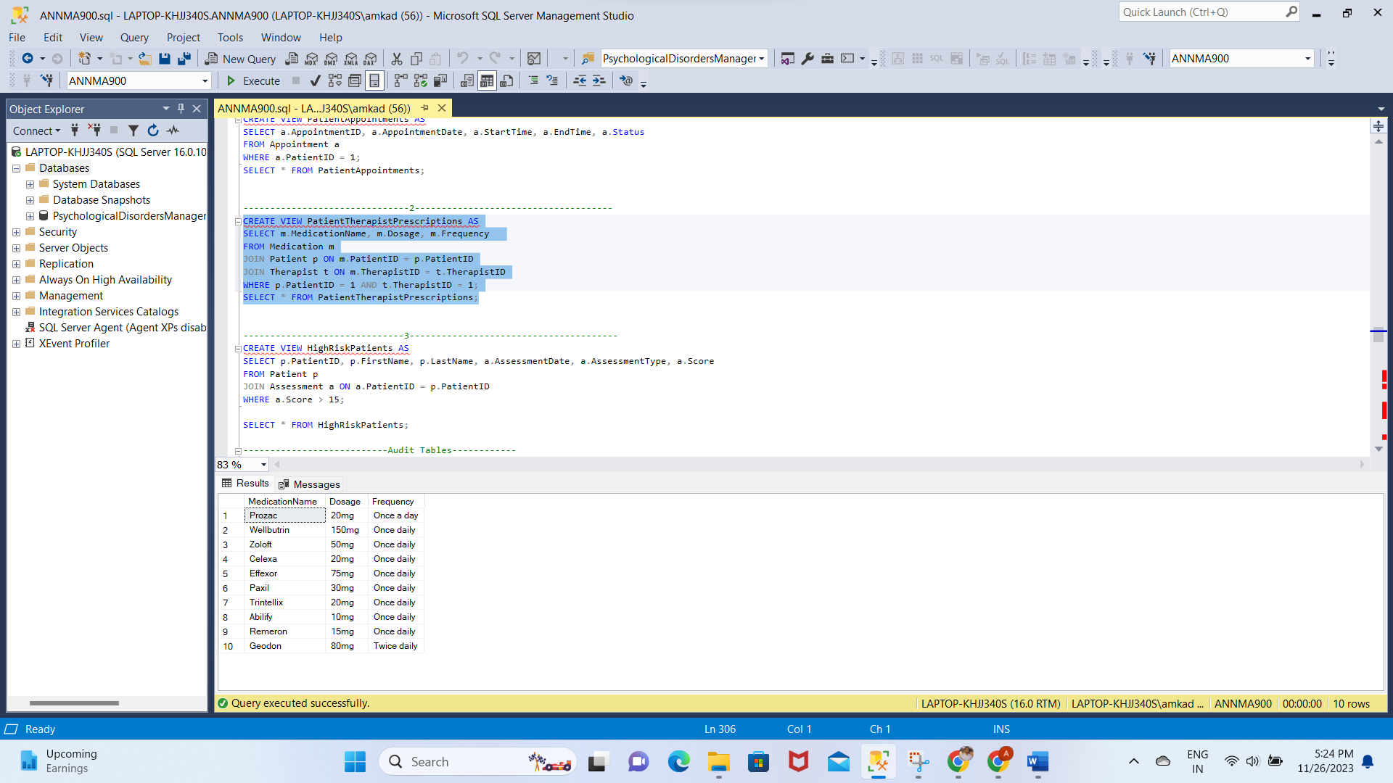

1. CREATE VIEW HighRiskPatients AS

SELECT p.PatientID, p.FirstName, p.LastName, a.AssessmentDate, a.AssessmentType, a.Score

FROM Patient p

JOIN Assessment a ON a.PatientID = p.PatientID

WHERE a.Score > 15;

SELECT * FROM HighRiskPatients;

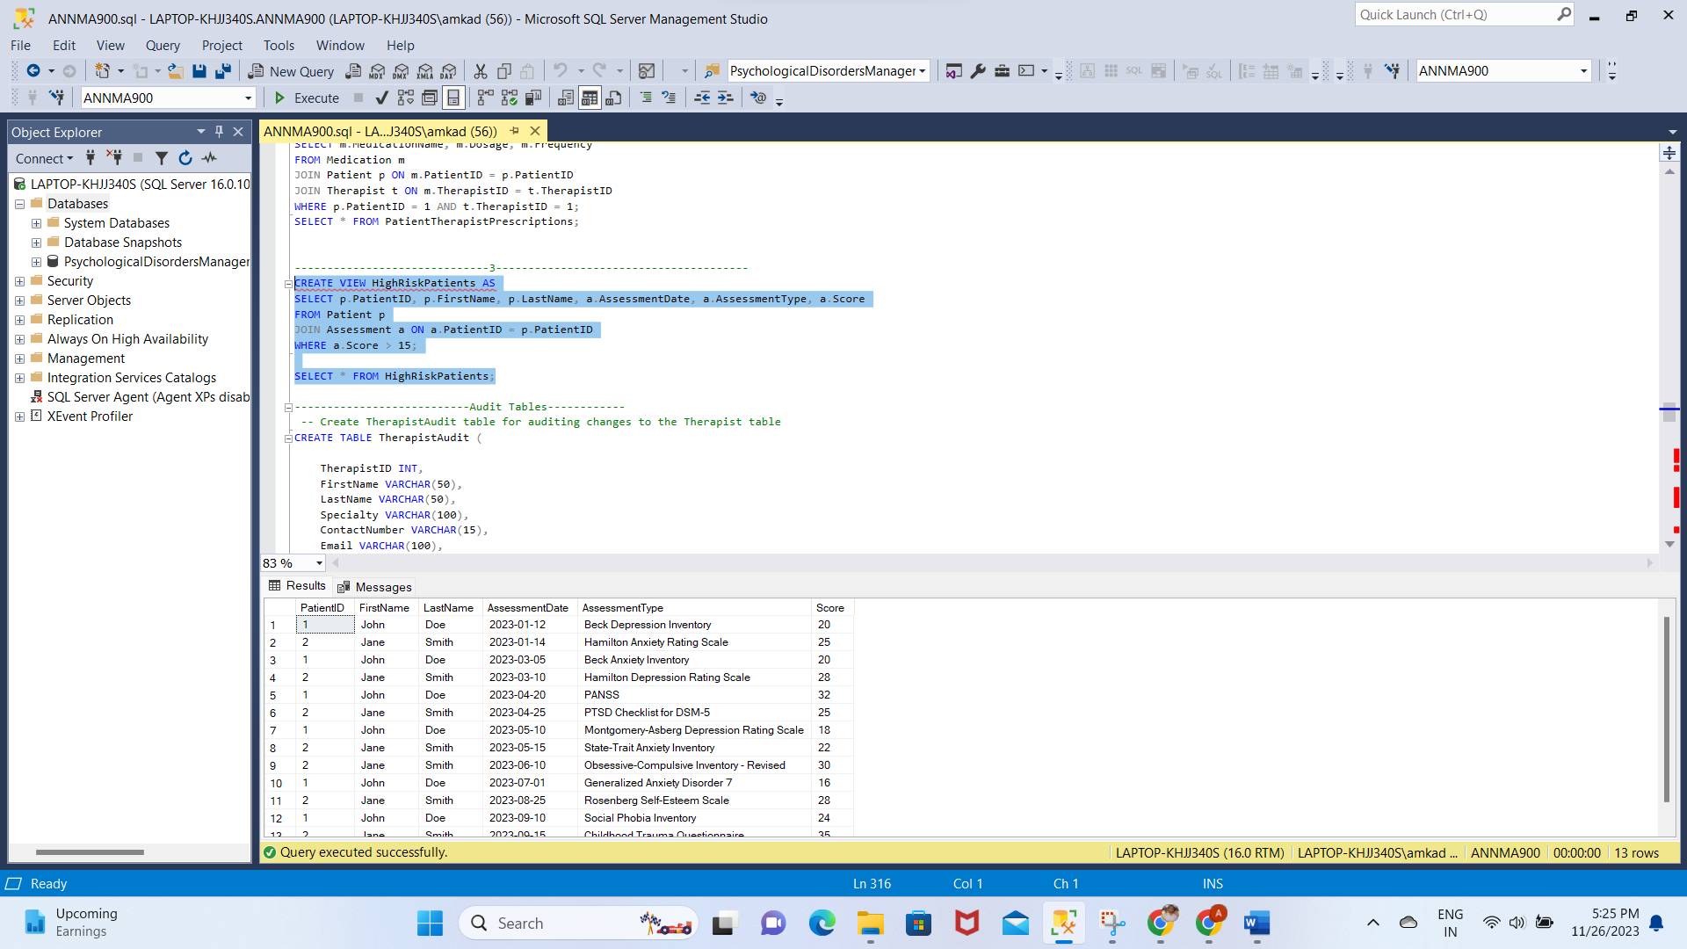

**Creating Audit Tables:**

CREATE TABLE TherapistAudit (

TherapistID INT,

FirstName VARCHAR(50),

LastName VARCHAR(50),

Specialty VARCHAR(100),

ContactNumber VARCHAR(15),

Email VARCHAR(100),

LicenseNumber VARCHAR(50),

DateTimeChanged DATETIME

);

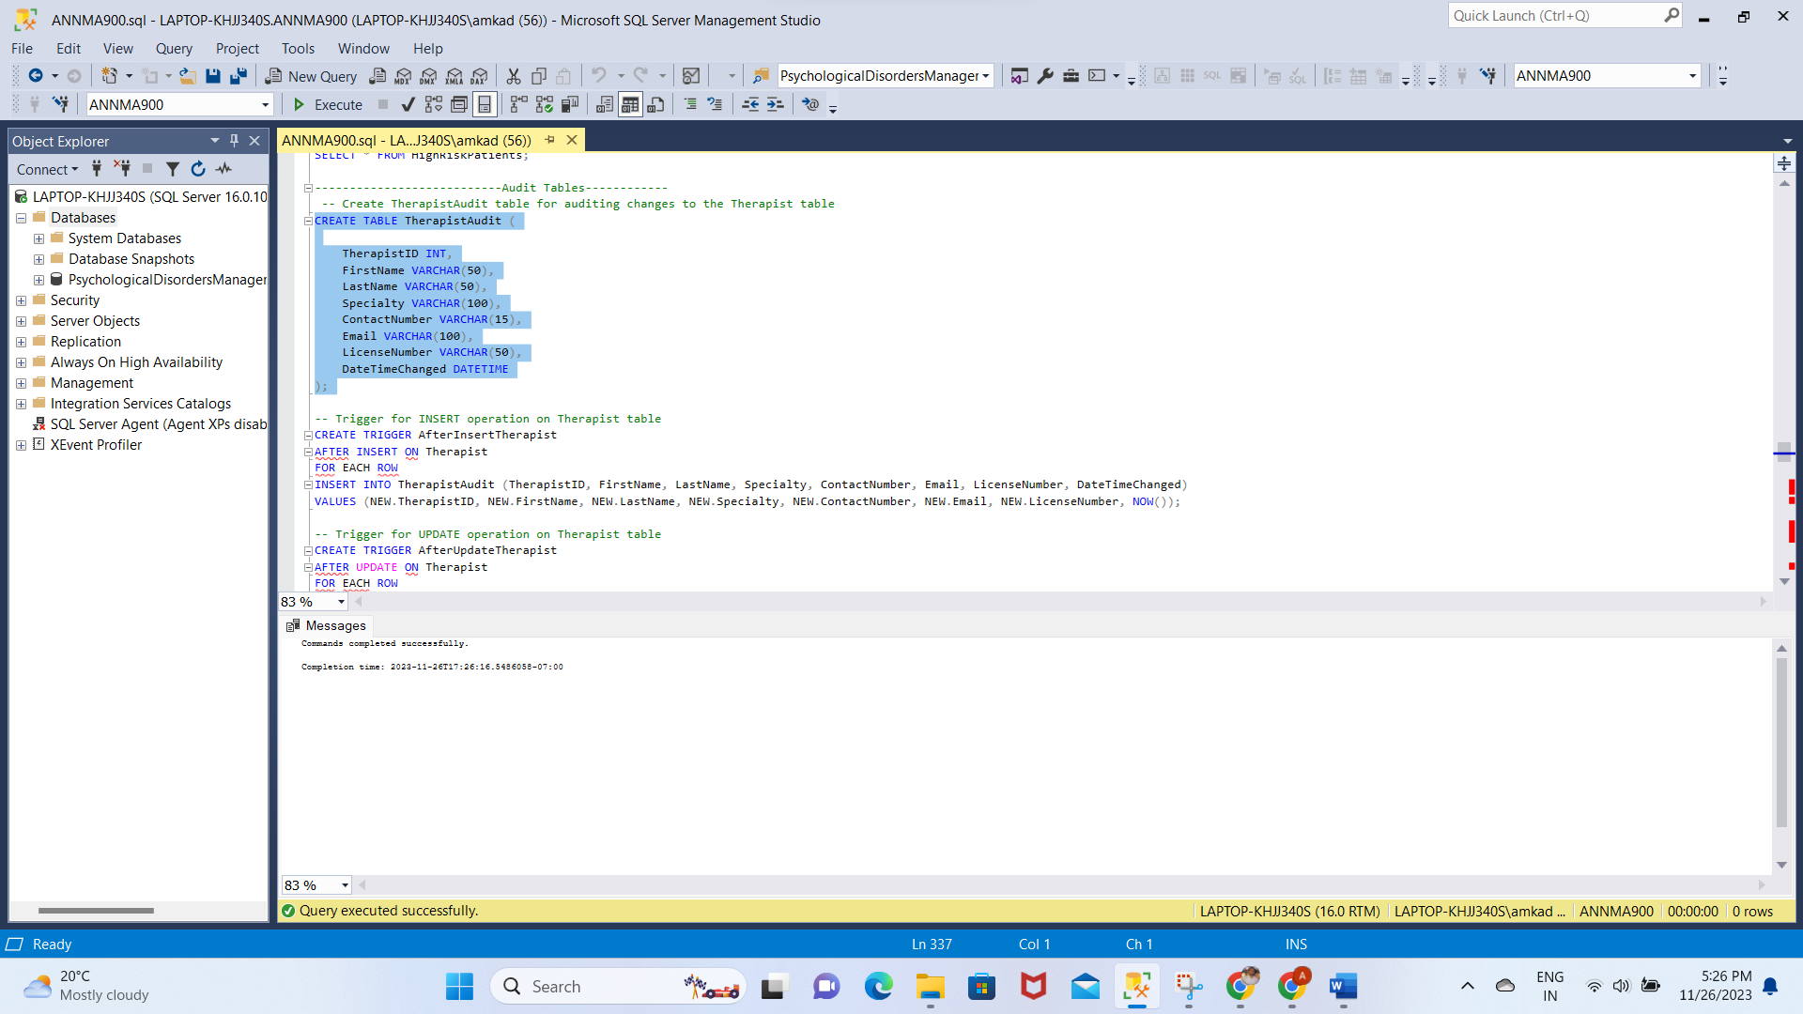

-- Trigger for INSERT operation on Therapist table

CREATE TRIGGER AfterInsertTherapist

AFTER INSERT ON Therapist

FOR EACH ROW

INSERT INTO TherapistAudit (TherapistID, FirstName, LastName, Specialty, ContactNumber, Email, LicenseNumber, DateTimeChanged)

VALUES (NEW.TherapistID, NEW.FirstName, NEW.LastName, NEW.Specialty, NEW.ContactNumber, NEW.Email, NEW.LicenseNumber, NOW());

-- Trigger for UPDATE operation on Therapist table

CREATE TRIGGER AfterUpdateTherapist

AFTER UPDATE ON Therapist

FOR EACH ROW

INSERT INTO TherapistAudit (TherapistID, FirstName, LastName, Specialty, ContactNumber, Email, LicenseNumber, DateTimeChanged)

VALUES (OLD.TherapistID, OLD.FirstName, OLD.LastName, OLD.Specialty, OLD.ContactNumber, OLD.Email, OLD.LicenseNumber, NOW());

-- Trigger for DELETE operation on Therapist table

CREATE TRIGGER AfterDeleteTherapist

AFTER DELETE ON Therapist

FOR EACH ROW

INSERT INTO TherapistAudit (TherapistID, FirstName, LastName, Specialty, ContactNumber, Email, LicenseNumber, DateTimeChanged)

VALUES (OLD.TherapistID, OLD.FirstName, OLD.LastName, OLD.Specialty, OLD.ContactNumber, OLD.Email, OLD.LicenseNumber, NOW());

--------Testing Audit Results------------

-- Insert a new therapist

INSERT INTO Therapist (TherapistID, FirstName, LastName, Specialty, ContactNumber, Email, LicenseNumber)

VALUES (11, 'Dr. Sarah', 'Williams', 'Family Therapist', '555-333-2222', 'sarah.williams@email.com', 'XYZ789');

Select*from Therapist

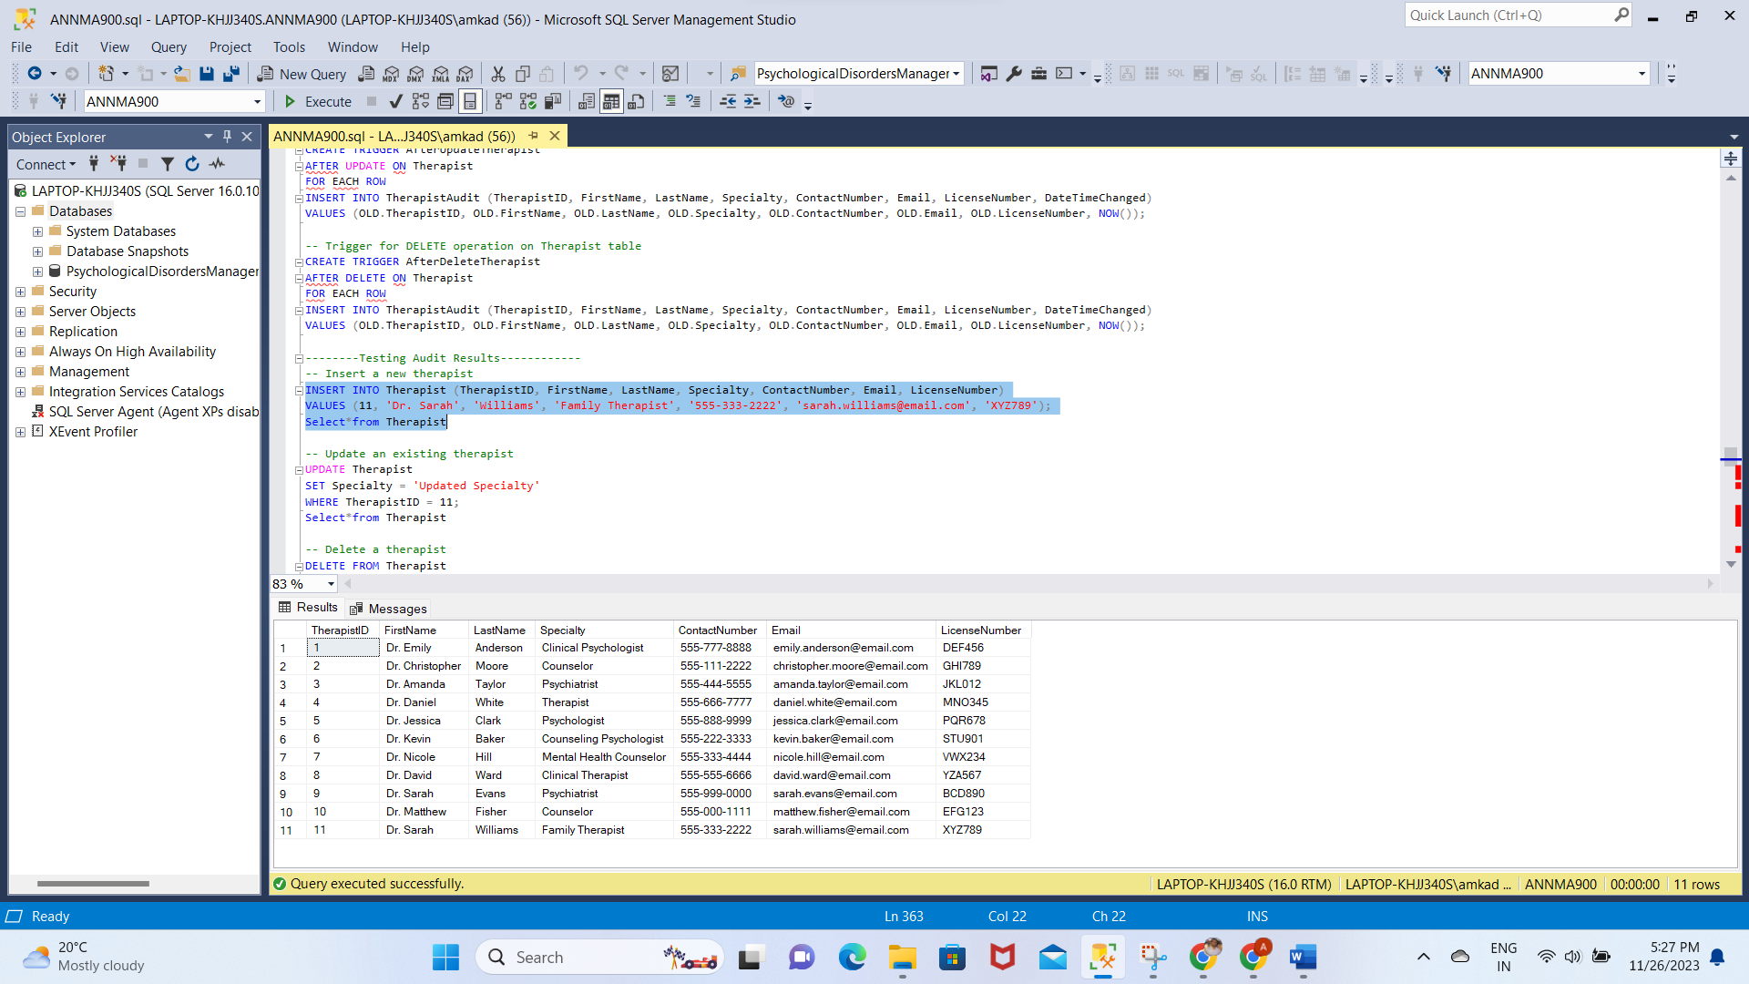

-- Update an existing therapist

UPDATE Therapist

SET Specialty = 'Updated Specialty'

WHERE TherapistID = 11;

Select*from Therapist

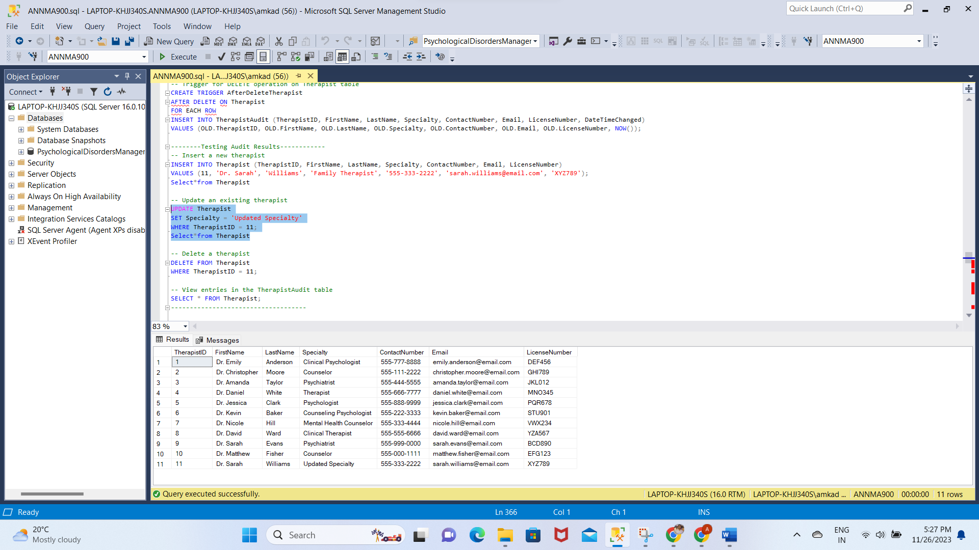

-- Delete a therapist

DELETE FROM Therapist

WHERE TherapistID = 11;

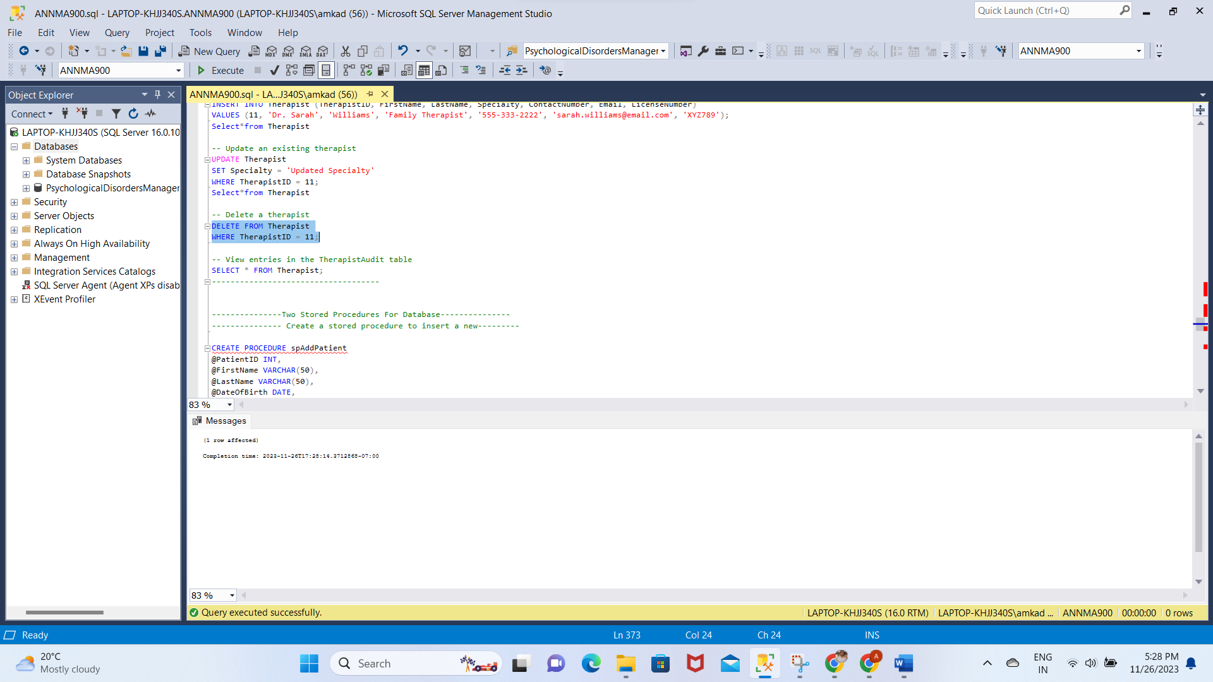

-- View entries in the TherapistAudit table

SELECT * FROM Therapist;

--------------------------

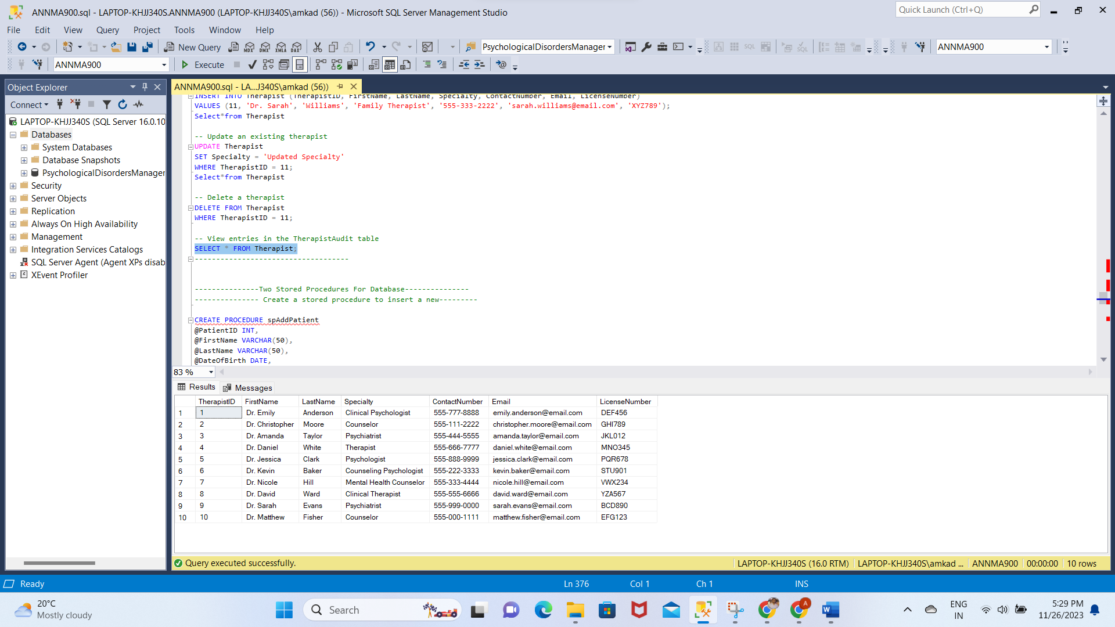

**Two Stored Procedures For Database:**

CREATE PROCEDURE spAddPatient

@PatientID INT,

@FirstName VARCHAR(50),

@LastName VARCHAR(50),

@DateOfBirth DATE,

@Gender VARCHAR(10),

@ContactNumber VARCHAR(15),

@Email VARCHAR(100),

@Address VARCHAR(255),

@EmergencyContactID INT,

@InsuranceID INT

AS

BEGIN

INSERT INTO Patient (PatientID,FirstName, LastName, DateOfBirth, Gender, ContactNumber, Email, Address, EmergencyContactID, InsuranceID)

VALUES (@PatientID, @FirstName, @LastName, @DateOfBirth, @Gender, @ContactNumber, @Email, @Address, @EmergencyContactID, @InsuranceID);

END

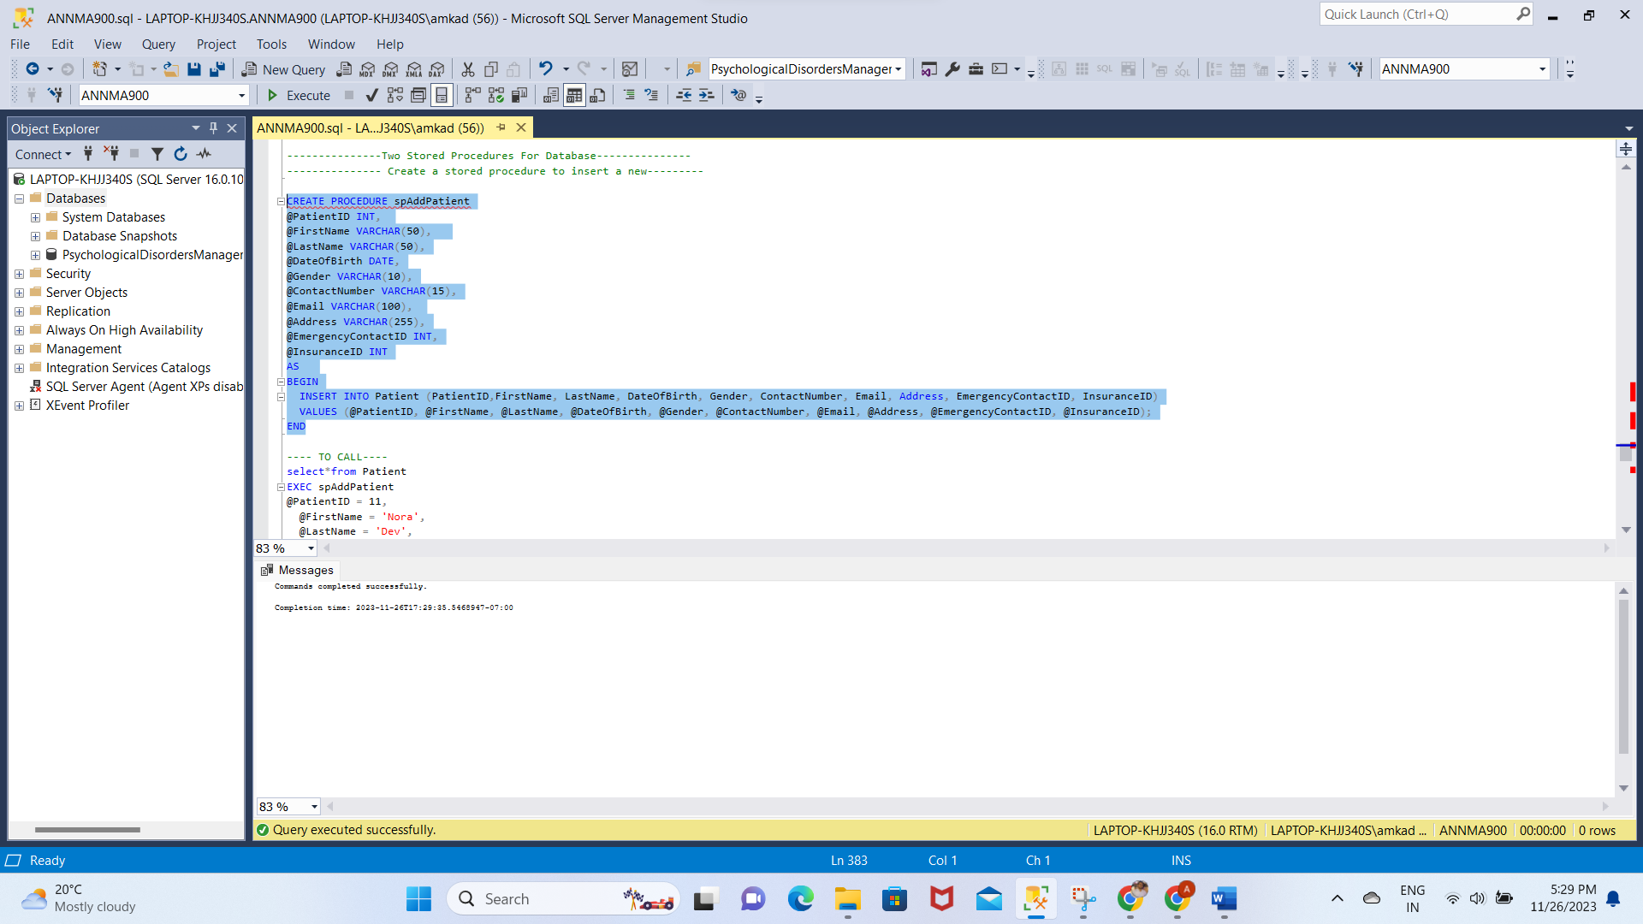

Before:

select*from Patient

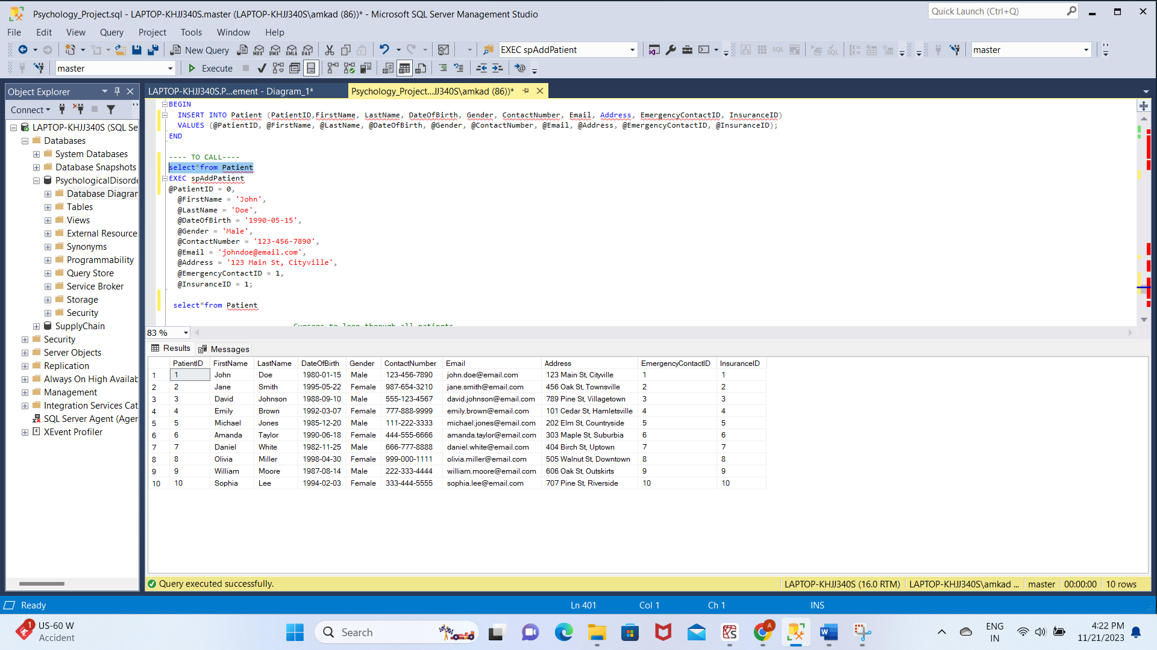

**After:**

EXEC spAddPatient

@PatientID = 11,

@FirstName = 'Nora',

@LastName = 'Dev',

@DateOfBirth = '1990-05-15',

@Gender = 'Female',

@ContactNumber = '123-654-7890',

@Email = 'Nora@email.com',

@Address = '321 Main St, tempe',

@EmergencyContactID = 9,

@InsuranceID = 11;

select*from Patient

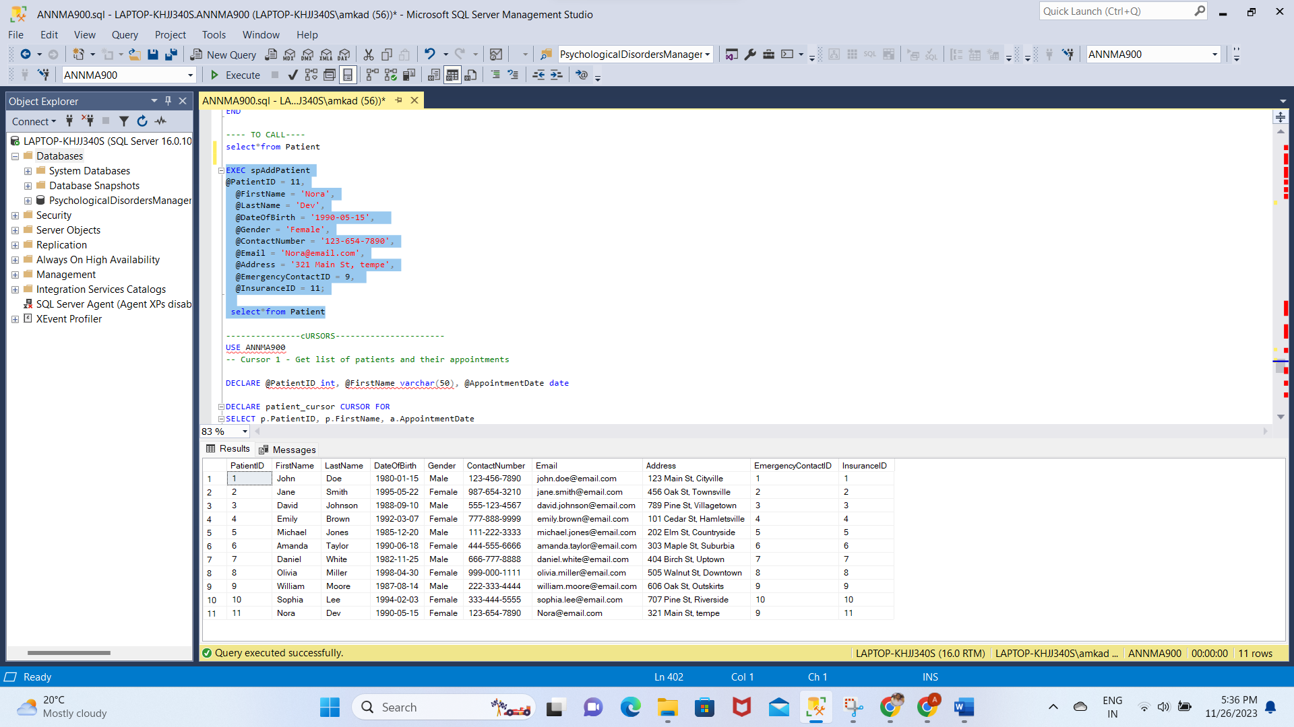

**TWO CURSORS:**

1. USE ANNMA900

-- Cursor 1 - Get list of patients and their appointments

DECLARE @PatientID int, @FirstName varchar(50), @AppointmentDate date

DECLARE patient_cursor CURSOR FOR

SELECT p.PatientID, p.FirstName, a.AppointmentDate

FROM Patient p JOIN Appointment a ON a.PatientID = p.PatientID

OPEN patient_cursor

FETCH NEXT FROM patient_cursor INTO @PatientID, @FirstName, @AppointmentDate

WHILE @@FETCH_STATUS = 0

BEGIN

PRINT 'Patient ' + @FirstName + ' (ID=' + CAST(@PatientID AS varchar) + ') has an appointment on ' + CAST(@AppointmentDate AS varchar)

FETCH NEXT FROM patient_cursor INTO @PatientID, @FirstName, @AppointmentDate

END

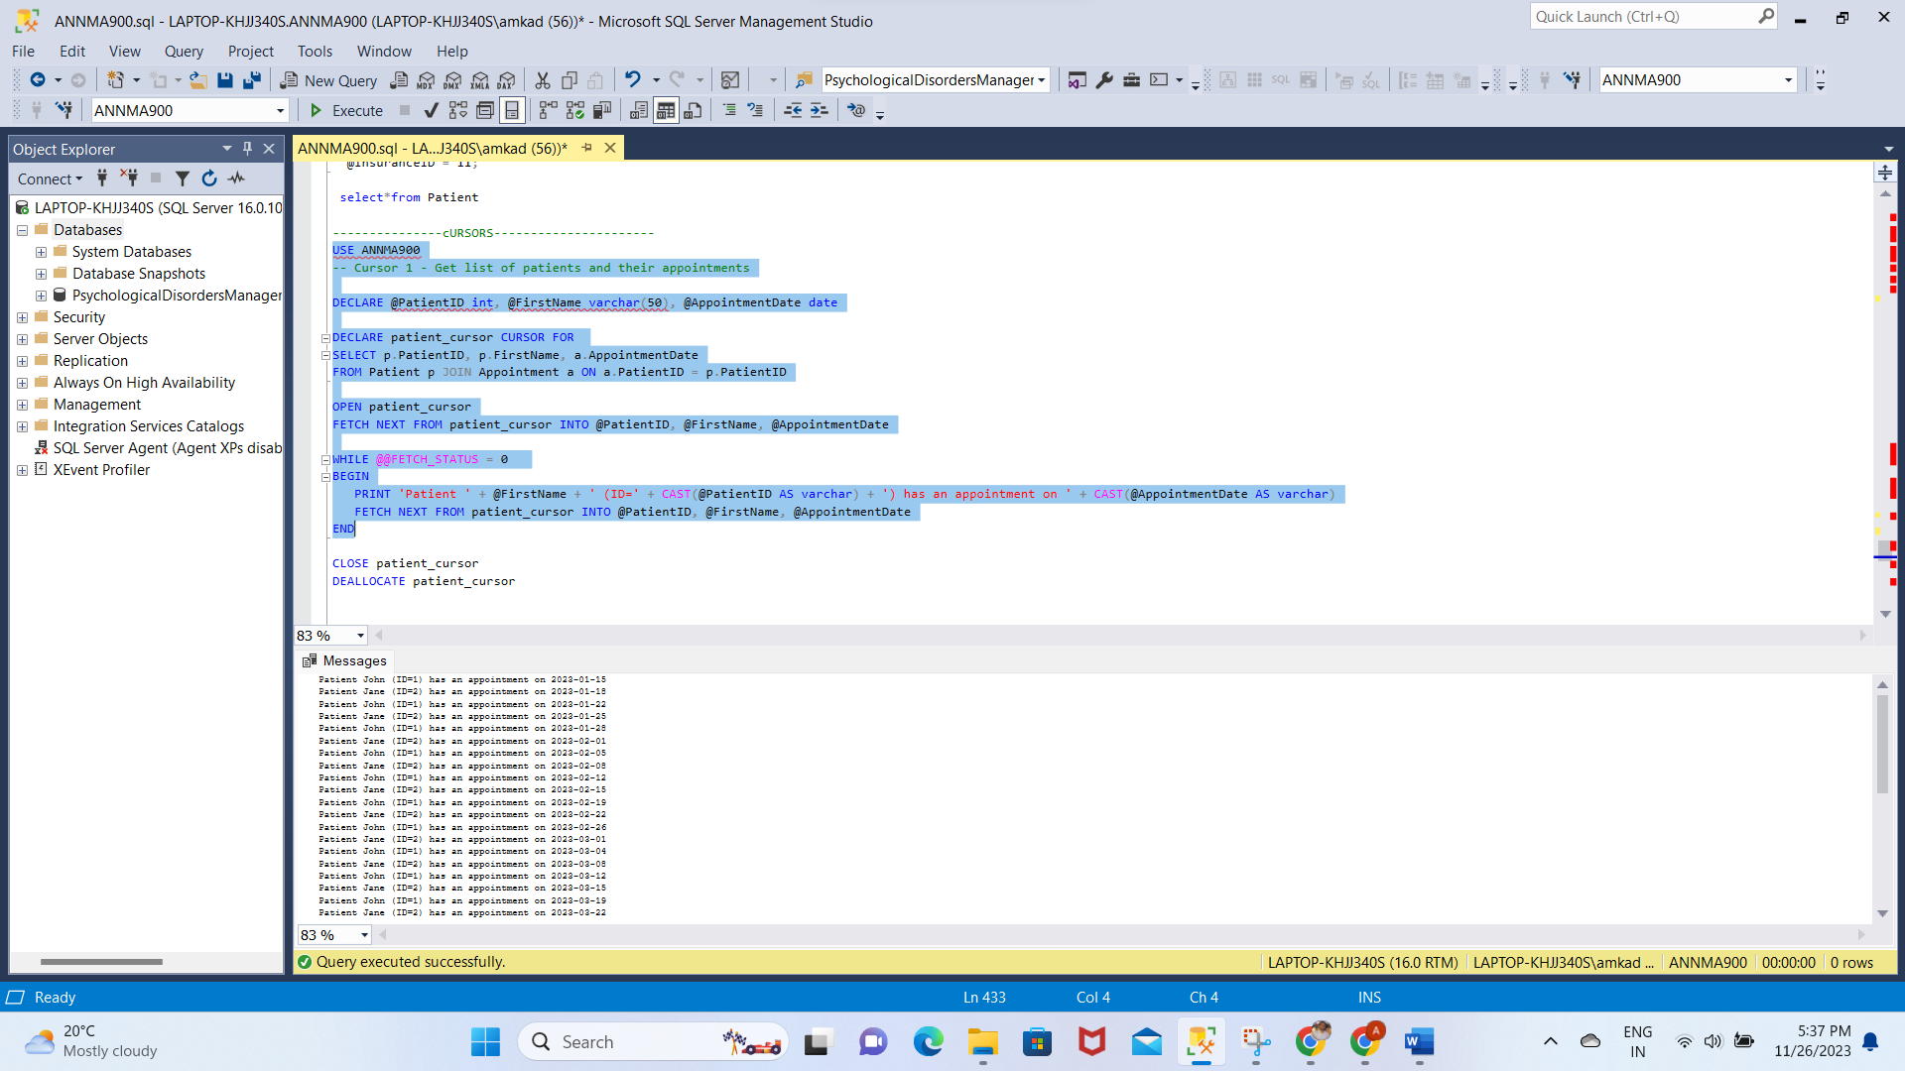

**AFTER:**

CLOSE patient_cursor

DEALLOCATE patient_cursor

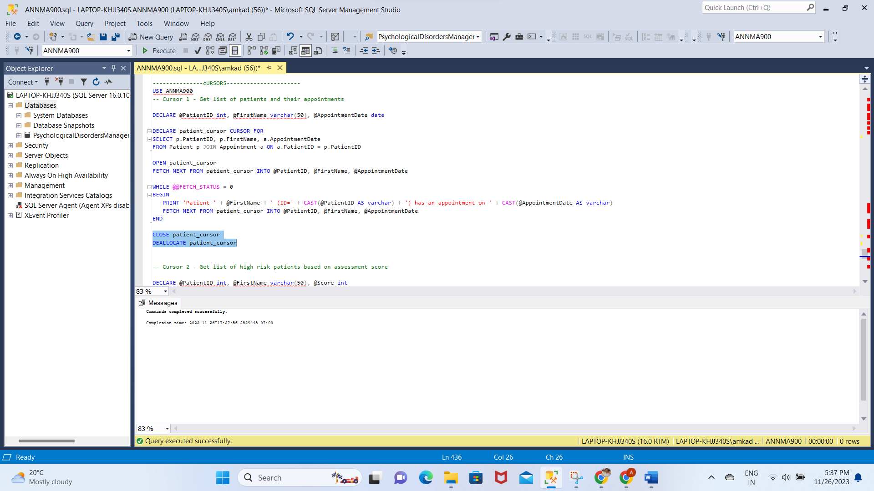

2.

DECLARE @PatientID int, @FirstName varchar(50), @Score int

DECLARE high_risk_cursor CURSOR FOR

SELECT p.PatientID, p.FirstName, a.Score

FROM Patient p JOIN Assessment a ON a.PatientID = p.PatientID

WHERE a.Score > 15

OPEN high_risk_cursor

FETCH NEXT FROM high_risk_cursor INTO @PatientID, @FirstName, @Score

WHILE @@FETCH_STATUS = 0

BEGIN

PRINT 'High risk patient ' + @FirstName + ' (ID=' + CAST(@PatientID AS varchar) + ') has score of ' + CAST(@Score AS varchar)

FETCH NEXT FROM high_risk_cursor INTO @PatientID, @FirstName, @Score

END

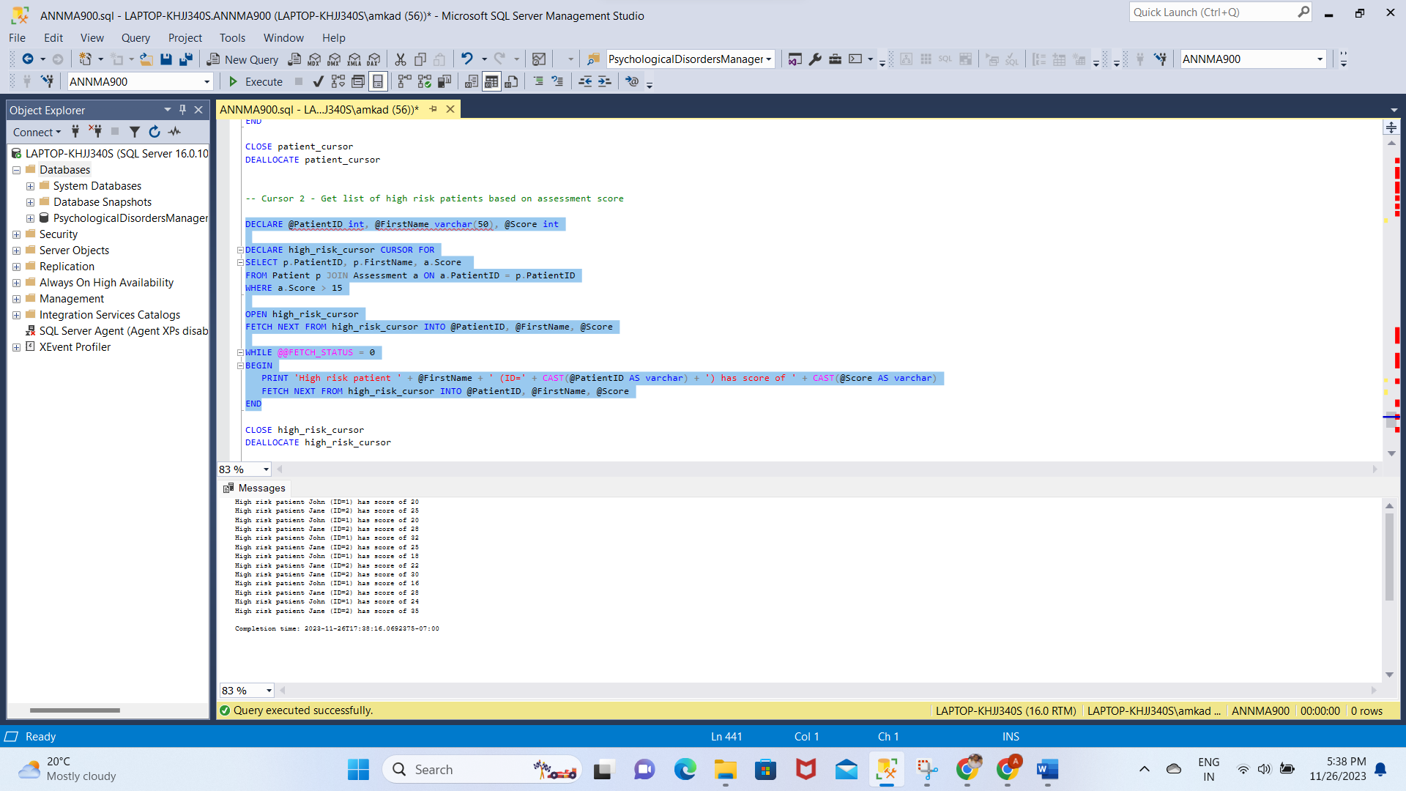

CLOSE high_risk_cursor

DEALLOCATE high_risk_cursor

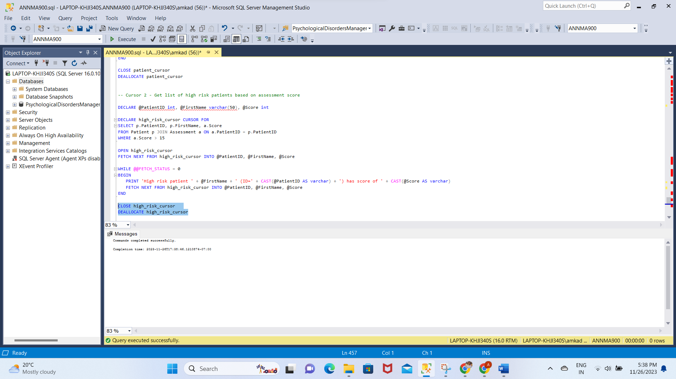

**DROP DATABASE**

DROP DATABASE ANNMA900

